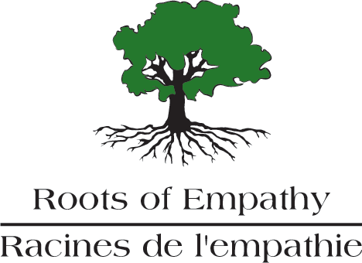

Are you a proud parent with a new baby?
Will your baby be 2 – 4 months old in October?

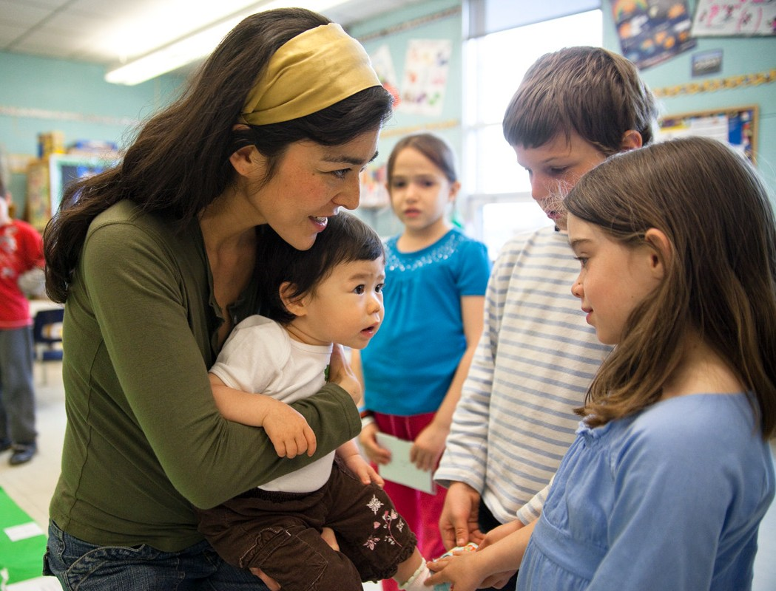
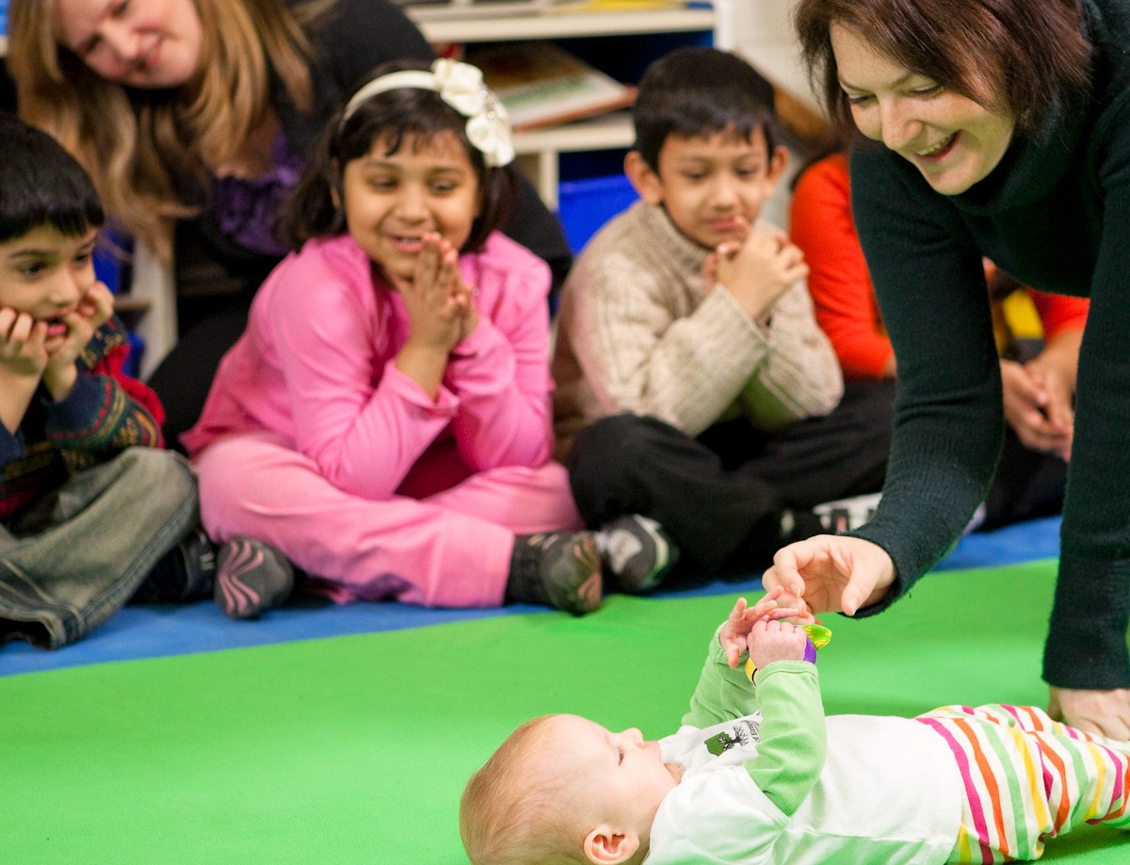
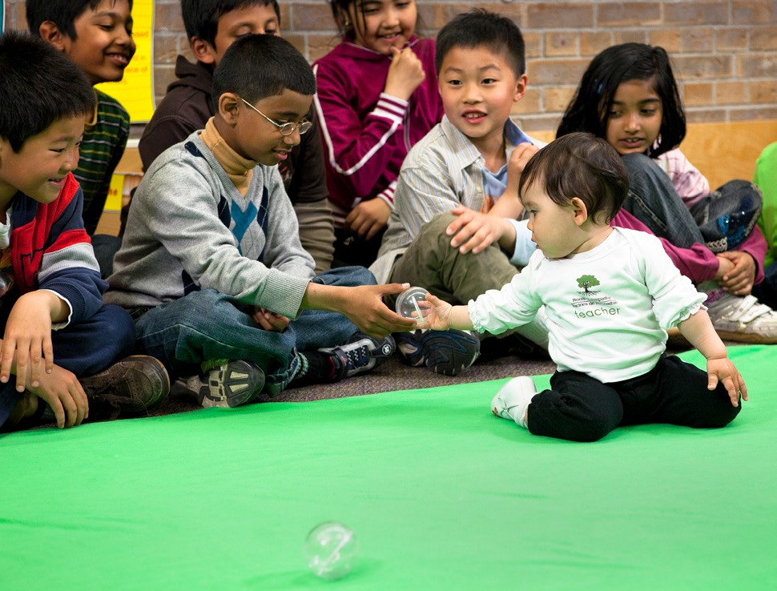
You and your baby could be a Roots of Empathy Family

Roots of Empathy is a program for elementary school children. The program’s aim is to increase empathy - the ability to understand how another person feels.
Children learn to care for and respect each other, and there is less bullying and aggression. To Be a Roots of Empathy Family.
- Nine times over the school year, you and your baby will visit a classroom with the Roots of Empathy Instructor and join the children around the “Green Blanket”. You will help the children learn all about your baby and in turn they will learn about themselves, their feelings, their temperament traits and their relationships with family and others.
- At the moment we expect to have our babies on “Green Blankets” in classrooms, however if public health or schools restrict visitors, you may be asked to participate virtually from home in our Roots of Empathy Recovery Program through photos and videos.
- Babies must be between 2 and 4 months old in October.
“Roots of Empathy is about changing the world, child by child.”
- Mary Gordon, Founder/President

For more information please contact:

2021 Baby Recruitment Poster

