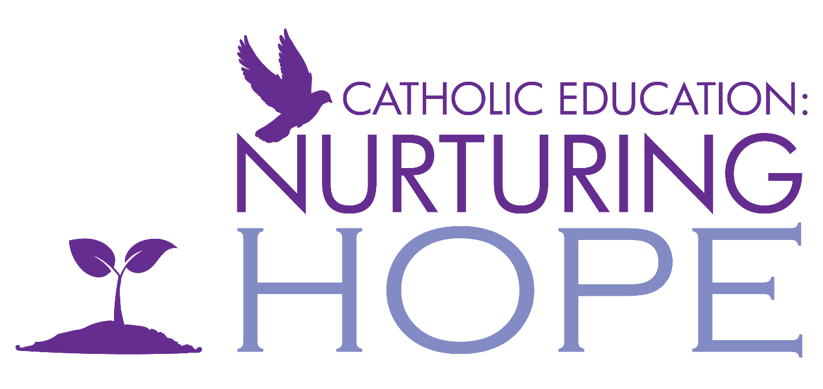

Catholic Education Week 2021
@ St. Teresa of Calcutta

Kindergarten: Ms. DeFlorio, Ms.Cabral & Ms. Scopelliti

Come join us in prayer and activities that nurture hope and kindness in our community. We will be gathering as a classroom community on Wednesday May 5th at 9:10am and/or 12:30pm to celebrate Catholic Education Week. Any and all family members are welcome!

Dear Kindergarten families, you are invited to join us on Thursday, May 6 from 8:35-9:00 am for a collaborative art activity. We look forward to nurturing hope as we work together with our loved ones.

Kindergarten: Mrs. Musselwhite & Mrs. Laic

Parents are invited on Wednesday, May 5th to join us for a read aloud of the creation bible story. After a discussion about what we can do to protect God’ s creations, students and parents will go on a nature walk as a family and pray together to thank God for all the beauty you see.

Dear Kindergarten families, you are invited to join us on Thursday, May 6 from 8:35-9:00 am for a collaborative art activity. We look forward to nurturing hope as we work together with our loved ones.

Kindergarten: Mrs. Matthews, Mrs.Mederios & Mrs. Laic
As a Catholic learning community, we would like to extend an invitation to our classroom family (parents/guardians) to join us for our Catholic Education Week celebration! On Wednesday May 5th from 8:30-9:00am, we will gather virtually to watch a short video of the Creation Story followed by a collaborative art activity and an outdoor scavenger hunt for God’s beautiful creations. We look forward to celebrating the distinctiveness of Catholic education, and sharing/growing in faith together with you and your child.

Dear Kindergarten families, you are invited to join us on Thursday, May 6 from 10:55-11:20 am for a collaborative art activity. We look forward to nurturing hope as we work together with our loved ones.

Grade 1: Mrs. Robinson
The Grade Ones will be Nurturing Hope through God's Creations. Join us on Friday as we continue to appreciate what God has given us and how we can work together to care for the Earth! Details will be posted on D2L.

Grade 2: Mrs. La Joie
Please join our class on Tuesday, May 4, 2021, 10:10-10:40 a.m. as we explore the story, “The Curious Garden,” written by Peter Brown. We will learn how dedication, perseverance and nurturing pays off and helps to create a beautiful environment and a sense of community.

Grade 2 & 3: Mrs. Lourenco
Mrs. Lourenco’s Gr2/3’s would like to invite you to their class for some poetry fun and parent-child collaboration on Wednesday, May 5th from 10:40am to -11:40am.

Grade 3 & 4: Ms. Kole
Please join us to create some beautiful Haiku poems about Hope!
Wednesday May 5, 2021 at 10:40am
See you then.
Grade 4: Mrs. Heaney
My class will be making crosses from natural and found items Tuesday afternoon at 1:20pm. They will be invited to do a "Walk With Jesus" with their family members on Wednesday. On Thursday they will be sharing their cross creations and sharing their walking experiences.

Grade 5: Ms. Kelly
Our class will be starting each day with a student led decade of the rosary, and on Tuesday we will be making crosses out of natural or found materials. We will make a collage of the images as a celebration of our connection to nature and our commitment to being stewards of the Earth.

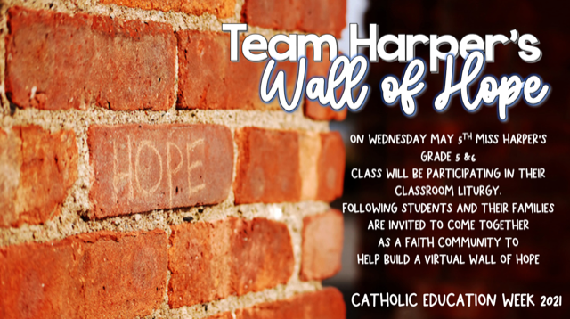
Grade 5 & 6: Ms. Harper
For Catholic Education Week my class will be doing a classroom virtual liturgy followed by creating a virtual wall of hope. We will be reflecting on how we can build each other up, spread hope and kindness.

Grade 6: Mrs. Santi
Miss Santi's grade sixes with be discussing the theme of Nurturing Hope and then assembling collages that inspire us to be hopeful.

The Community Living Classroom: Mr. Prezens

The CLC will be exploring the theme of “Nurturing Hope” through a variety of children’s books that honour growth in the face of adversity.

Grade 7s & 8s: Ms. DeSouza, Mr. Barber & Mr. Mount

This year, for Catholic Education Week, the intermediate team would like to invite you each morning, to sit alongside your child as they participate in a student- led prayer service. Each service will be facilitated by a group of students centered around the theme of Nurturing Hope. As we move through our busy days, we hope you will join us in a quiet moment each morning, to gather in faith.

