St. Peter CES Confirmation of Daily Covid-19 Student Screening Log

Student Name : ________________________________________ Class : ___________________
(Please Print)

Parent/Guardian Name: ________________________________ Date : _______________
(Please Print)

Verify in writing: |  | Verify electronically:  https://covid-19.ontario.ca/school-screening/  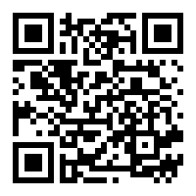  Students may alternatively complete screening on their own device, where age appropriate, and present on arrival.
I/we confirm the student (above) received a “pass” on the COVID School Screening Tool.
______________________________________________
Parent/Guardian Name (Print)

______________________________________________
Parent/Guardian Signature

Please initial each morning prior to attending school.

By initialing below, I/we confirm the Ontario COVID-19 School Screening has been completed for my child and my child has passed the screening.

Date | Parent/guardian initials
September 7, 2021
September 8, 2021
September 9, 2021
September 10, 2021
September 13, 2021
September 14, 2021
September 15, 2021
September 16, 2021
September 17, 2021

Daily self-screening for all students continues to be a requirement to come to school beyond September 17, 2021. Thank you for working together to keep our school safe.

