Hello Families!

Let’s make lunch easier with Lunchbox Orders:

[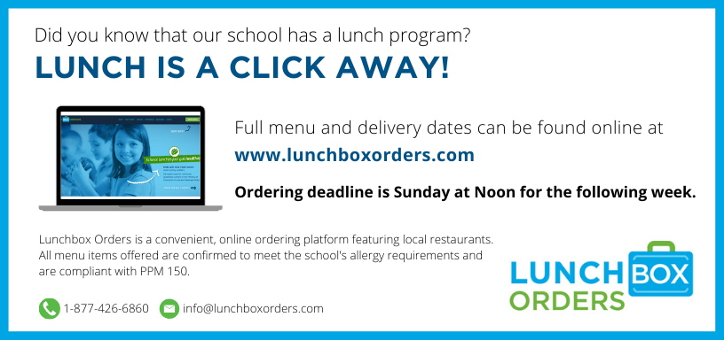](http://www.lunchboxorders.com/)

**How to Order:**

1. Go online at [www.lunchboxorders.com](http://www.lunchboxorders.com) and click “ORDER LUNCH”.
2. **New to Lunchbox Orders?**  Click “Create an Account” to register your family’s account.
3. **Already registered?**  Please login directly with your current user name (e-mail address) and password.
4. Add your child to your account by clicking “add a student” and register your child with their new teacher and grade for the current school year. ***\*\* Please ensure the correct teacher and grade are selected to prevent errors on delivery days.***
5. Click “Order Now” (beside your child’s name) to access the school’s ordering calendar.
6. Proceed with ordering your child’s lunch by clicking on the blue box for each restaurant featured.
7. All orders are submitted on the website and payment is processed on-line by Visa, MasterCard, Discover, Debit MasterCard or Visa Debit.  Visa and MasterCard prepaid cards are also accepted.

**The Benefits:**

1. With every meal purchased, a contribution will be made to the school’s fundraising program.
2. Lunchbox Orders is paperless and cashless.  Ordering online is fast and easy!
3. All menu items featured are compliant with the Ontario Ministry of Education’s Food and Beverage Policy.
4. Orders may be placed weekly or in advance, for the full length of the program.

**Things to Remember:**

* New orders must be placed by Sunday at 12pm (NOON) for the following week.
* Orders will not be accepted after the Sunday deadline.
* Cancellations will be accepted two (2) days prior to delivery.

**Questions?** Contact the Lunchbox Orders customer service team at **1.877.426.6860** or by e-mail at [**info@lunchboxorders.com**](mailto:info@lunchboxorders.com)