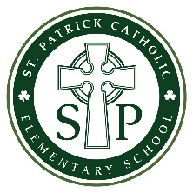

Catholic School Council

AGENDA
May 20, 2020 | St. Patrick School Library | 6:30 pm

TIME | TOPIC | PRESENTER

7:00 pm | Welcome | R. DeLuca Malette
7:00 – 7:05 pm | Approval of Agenda
7:05 – 7:15 pm | Principal’s Report | R. DeLuca Malette
7:15 – 7:25 pm | Student Engagement Sharing – Upcoming Events  - Virtual Talent Show | R. DeLuca Malette
7:25 – 7:35 pm | Virtual Family Engagement Update  - Kindergarten Parent Orientation  - Graduation | R. DeLuca Malette
7:35 – 7:50 pm | Proposals: Committees Update and Assignments  - 50th Anniversary | R. DeLuca Malette
7:50 – 7:55 pm | Action Items Recap | J. Boere
8:00 pm | Adjournment | All

