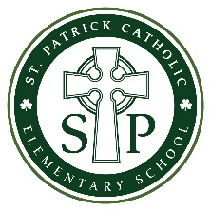

Catholic School Council

AGENDA
April 15, 2020 | Microsoft Team Meeting | 7:00 pm

TIME | TOPIC | PRESENTER

7:00 pm | Welcome | R. DeLuca Malette
7:00 – 7:05 pm | Approval of Agenda | R. DeLuca Malette
7:05 – 7:15 pm | Principal’s Report & Financial Report | R. DeLuca Malette
7:15 – 7:30 pm | Distance Learning  - Info to share about Phase 2 – Distance Learning  - Questions/Feedback re: Phase 2 – Distance Learning | R. DeLuca Malette
7:30 – 7:35 pm | Annual Fundraiser Update  - Mardi Gras Fundraiser | R. DeLuca Malette
7:35 – 7:45 pm | Family Engagement Update  - PRO Grant events – postponed?  - June BBQ – September? | R. DeLuca Malette
7:45 – 8:00 pm | Proposals: Committees Update and Assignments  - 50th Anniversary planning | R. DeLuca Malette
8:00 pm | Action Items Recap | J. Boere
8:00 pm | Adjournment | All

