Welcome St. Matthew Catholic Elementary School!
We are happy to share that Lunchbox by SchoolCash Online will be offered at your school for the 2021/2022 school year!
Lunchbox is a convenient, online ordering platform featuring local vendors. An ordering calendar has been coordinated for the school community and can be found on your SchoolCash Online items page.
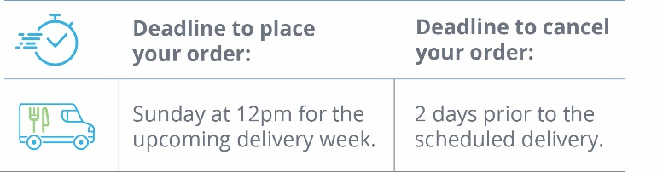
The ordering calendar will open on Tuesday, November 9, 2021 and will feature the following options:
Delivery Day | Featured Restaurant
Tuesday | Pizza Pizza
Wednesday | Subway
Thursday | Pizza Pizza
How to Order:
- Go to your SchoolCash Online account items page and click “ORDER NOW”.
- Confirm your child’s account information including their new teacher and grade for the current school year. **Please ensure the correct teacher and grade are selected to prevent errors on delivery days. There will be two groups: Gr. 1 – Gr. 4 & FDK, Gr. 5 – Gr. 8.
- Proceed with ordering your child’s lunch on the school’s ordering calendar by clicking on the blue date for the scheduled vendors.
- All orders are submitted on the website and payment is processed on-line by Visa, MasterCard, Discover, Debit MasterCard or Visa Debit. Visa and MasterCard prepaid cards are also accepted.
Important Dates:
- Lunch delivery is scheduled to begin Tuesday, November 23, 2021.
- Orders may be placed weekly or in advance, for the full length of the program.
- Sunday, November 21, 2021 at NOON (12pm) is the ordering deadline for the first scheduled LUNCH delivery.
Things to Remember:
- The ordering deadline is Sunday at 12pm (NOON) for the upcoming delivery period.
- New orders will not be accepted after the Sunday deadline.
- If buses are cancelled due to inclement weather, lunches will be delivered as scheduled.
- If there is a school closure, lunches will be cancelled and a credit will be issued within 3 business days.

