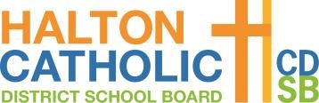

St. Matthew Catholic School
Wednesday, September 1st, 2021
9:00am – 3:30pm

To ensure readiness for the 2021-22 school year, the ministry encourages schools to address the following topics prior to the start of student instruction:
- health and safety protocols
- mental health and well-being
- learning recovery and intervention strategies

Welcome & Prayer

Policy and Procedures – via TEAMS
Health and Safety Protocols
High Priority Policies and Procedures

Break

Mental Health and Well-Being for Staff and Students
Return to school overview

Lunch

Mental Health and Well-Being for Staff and Students
Resources Review

Break

Explore, Reflect, Prepare
Mentally Healthy Classrooms

