Student Name : ___________________________________ Class : __________________________
(Please Print)

Parent/Guardian Name: __________________________________ Date : _______________
(Please Print)

Verify in writing: |  | Verify electronically:  https://covid-19.ontario.ca/school-screening/  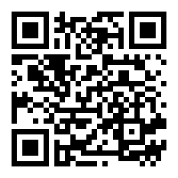  Students may alternatively complete screening on their own device, where age appropriate, and present on arrival.
I/we confirm the student (above) received a “pass” on the COVID School Screening Tool.
______________________________________________
Parent/Guardian Name (Print)

______________________________________________
Parent/Guardian Signature

Please initial each morning prior to attending school.

By initialing below, I/we confirm the Ontario COVID-19 School Screening has been completed for my child and my child has passed the screening.

Date | Parent/guardian initials
January 3, 2022 | NO SCHOOL. Delayed Entry.
January 4, 2022 | NO SCHOOL. Delayed Entry.
January 5, 2022
January 6, 2022
January 7, 2022
January 10, 2022
January 11, 2022
January 12, 2022
January 13, 2022
January 14, 2022
Daily self-screening for all students continues to be a requirement to come to school. Thank you for working together to keep our school safe

