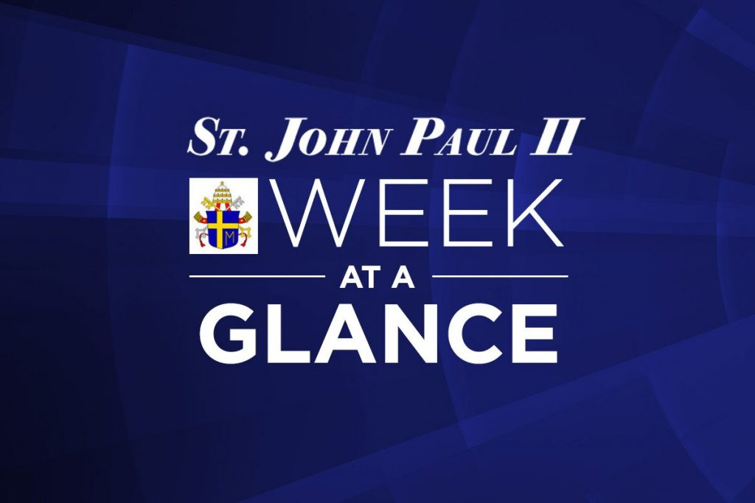
St. John Paul II Catholic School
Weekly Update #28
Monday April 1st - Friday April 5th, 2019
Celebrations:
Public Speaking: We are so proud of Ava and Kayla, who represented St. John Paul II at the French Public Speaking Competition on Thursday evening. They both spoke with poise and confidence – way to go, felicitations!
Basketball: We congratulate our girls’ basketball team who continue to meet with success in the Oakville playoffs. The girls were crowned Oakville champions Thursday evening! Way to girls and Coach Kay!! We wish them continued success as they face teams from Burlington, Milton and Halton Hills next week!
Peer Mentoring: We enjoyed our final peer mentoring session this past week. We are very grateful for the leadership demonstrated by our Grade 7 and 8 mentors and we appreciate the dedication and engagement of our Grade 3 mathematicians!
Council Corner:
Our last School Council meeting was held on Monday March 4th. To access the minutes, please click on the link below.
Mon. April 1st | - Pizza Day
Tues. April 2nd | - Little Jammers after school
Wed. April 3rd | - Lunch Box – Boston Pizza  - Christian Meditation at 12:50
Thurs. April 4th | - Grade 8 classes on Student Success trip in the morning  - Lunch Box –Harvey’s  - Grade 1/4 Reading Club takes place at lunch recess
Fri. April 5th | - Pita Pit lunch

Reminders: Please see below for some important reminders and information.
West Kiss ‘n’ Ride in the Morning: We appreciate the hustle and bustle of the morning routine for most families. Please be reminded that if you are getting out of your vehicle, we ask you to park in the parking lot and escort your child safely through the parking lot to the sidewalk or the fence. The driveway is for Kiss ‘n’ Ride traffic only, where the driver does not park and exit the vehicle. We greatly appreciate your assistance in helping us to keep morning drop-off as smooth and safe as possible for everyone.
EQAO Dates: As mandated by the Ministry of Education, our Grade 3 and Grade 6 students will write the standardized test developed by EQAO, which stands for Education Quality Assessment Office. We have scheduled the Grade 3 students to write EQAO on May 22nd, 23rd, and 24th. We have scheduled our Grade 6 students to write EQAO on May 24th, 27th and 28th. (Please note a slight change in these dates from last week’s update.) We advise you of these dates well in advance and appreciate you scheduling any appointments for your child outside of these dates. Thank you in advance for your efforts to accommodate this request.
Planning for 2019-2020: Although it may be hard to believe, we are already beginning the planning process for the 2019-2020 school year. If you have a child entering Kindergarten in September, and you have not already registered your child, please do so at the earliest opportunity. Also, if you are moving and your child/children will be going to a new school, please let us know as soon as possible. Thank you!
Ontario Catholic School Graduate Expectation for the month of April: A Caring Family Member
I CARE!
I love God, myself and my family.
I care about and respect my ‘family’ at school, at Church, in the community, and the world.
I care about and respect God’s creation and everything in it.
Because I care, I pray for all my families, and I will live my life like Jesus.

We will be focusing on how students can demonstrate this expectation each and every day at school. Please take some time to talk to your child/children about how they can also demonstrate this expectation at home and in the community.

Upcoming Dates/Events:
- April 9th – Grade 4 trip to Gregg LeRock concert
- April 9th – Junior Battle of the Books competition
- April 10th – Grade 2 Liturgy
- April 11th – Senior Battle of the Books competition
- April 12th – P.A. Day – Numeracy
- April 15th – Catholic School Council meeting – All are welcome!
- April 16th – Parish Rosary visits
- April 18th – Stations of the Cross Liturgy at 10:30 a.m. – All are welcome!
- April 19th – Good Friday -no school for staff and students
- April 22nd – Easter Monday – no school for staff and students
- April 25th – Grade 7 day at Loyola
- April 29th – Student Award of Excellence Celebration at Holy Trinity

