Confirmation of Daily Covid-19 Student Screening Log
Parents/guardians/students must complete the Ontario School Screening Tool each morning prior to or upon arrival for each student. Confirmation of the daily screening must be provided to the classroom teacher upon entry into the school.
Student Name: ________________________________________ Class: ___________________
(Please Print)

Parent/Guardian Name: ________________________________ Date: _______________
(Please Print)
Verify in writing: |  | Verify electronically:  https://covid-19.ontario.ca/school-screening/  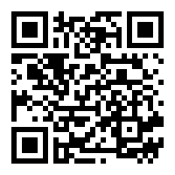  Students may alternatively complete screening on their own device, where age appropriate, and present on arrival.
I/we confirm the student (above) received a “pass” on the COVID School Screening Tool.
______________________________________________
Parent/Guardian Name (Print)

______________________________________________
Parent/Guardian Signature
. Please initial each morning prior to attending school.
By initialing below, I/we confirm the Ontario COVID-19 School Screening has been completed for my child and my child has passed the screening
Date | Parent/guardian initials
January 3, 2022
January 4, 2022
January 5, 2022
January 6, 2022
January 7, 2022
January 10, 2022
January 11, 2022
January 12, 2022
January 13, 2022
January 14, 2022

