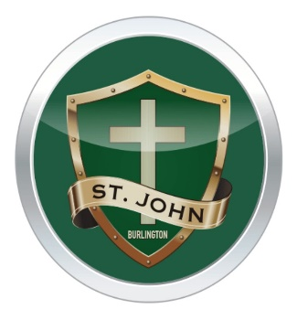
St. John Spring Fun Fair Gift Basket Raffle Themes
June 6, 2019

Dear Parents/Guardians.
It is time for our first Spring Fun Fair. As part of the fun we are asking classes to put together raffle baskets that will be on display in the school starting June 3rd. Raffle tickets will be on sale throughout the week and at the Fun Fair, with the draws occurring at 7 PM on Thursday evening. Tickets will be $2 each or 3 for $5.
Donated basket items are kindly asked to be brought in by Wednesday, May 29th. Items can begin to be sent in immediately. Thank you in advance for your generosity!
St. John School Council
Mrs. Savel | Summer Sleepovers: outdoor games, snacks, craft supplies, sleep accessories
Mrs. Sehn/Mrs. Manzin | Rainy Day Fun: board games, stuffies, lego
Mrs. Carubba/Ms. Frame | Beachtime Fun: beach toys, towels, picnic accessories
Mrs. Servenis | Ice Cream, Ice Cream: all the accessories you can think of!
Ms. Dalli | Bakers Delight: Baking accessories
Mrs. Daly | Pokemon, BeyBlades and LOL fun…all the things a 7 year old loves
Mrs. Freitas-Paprocki | Sporting Life: Everything sport related
Mrs. Fazzari | Arts and Crafts Fun!
Mrs. Agro | Oh the Drama: music, movies, and dramatic fun. Everything you might need for a night at the threatre
Mrs. Medeiros | Street Party Fun: bubbles, chalk, party supplies etc
Ms. Rosehart | Backyard BBQ Fun: sounds yummy!
Mrs. Hinkley | Back to school fun: all the things one will need for starting school in September
Mr. Haase | Movie Time Fun: Gift cards, popcorn, movie themed toys
Ms. Strkalj/Mr. Nagy | Gift cards and Sweets: what more could a 13 year old ask for?

