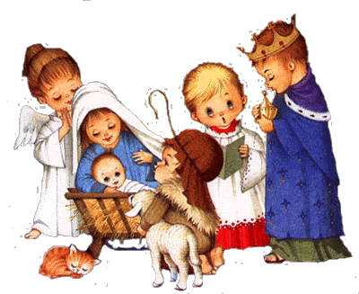
Mary Mother of God Church Christmas Pageant 2019

Children in GRADE 4 to grade 12 high school are invited to participate in our parish Christmas Pageant and Christmas liturgy! (high school students may volunteer to assist)

They must attend the following rehearsals at the church:

Saturday December 14th – 9:30 to noon
Saturday December 21st – 9:30 to noon
Saturday December 24th- 3:00 pm (run through and get ready) and stay for 5 p.m. mass.

We will have a nut-free snack at these rehearsals and the children are asked to bring a water bottle to each rehearsal. High school aged Youth are welcomed and can receive volunteer hours.

Please confirm your commitment to participating in the pageant by emailing me at cggamble@cogeco.ca. /or texting Colleen at 905-330-9537

We look forward to putting on the Best Christmas Pageant Ever (again)!

Thank-you,
Colleen Gamble, Lynda Ongaro & Sandy Goncalves

