St. Catherine Confirmation of Daily Covid-19 Student Screening Log

Student Name : Class :
(Please Print)

Parent/Guardian Name: Date :
(Please Print)

Verify in writing: |  | Verify electronically: https://covid- 19.ontario.ca/school- screening/  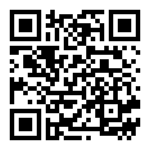  Students may alternatively complete screening on their own device, where age appropriate, and present on arrival.
I/we confirm the student (above) received a “pass” on the COVID School Screening Tool.

Parent/Guardian Name (Print) Parent/Guardian Signature

Please initial each morning prior to attending school.

By initialing below, I/we confirm the Ontario COVID-19 School Screening has been completed for my child and my child has passed the screening.

Date | Parent/guardian initials
January 3, 2022.
January 4, 2022.
January 5, 2022.
January 6, 2022.
January 7, 2022.
January 10, 2022.
January 11, 2022.
January 12, 2022.
January 13, 2022.
January 14, 2022.

Daily self-screening for all students continues to be a requirement to come to school beyond January 14th, 2022. Thank you for working together to keep our school safe.

