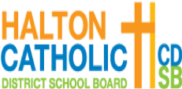

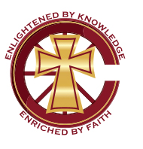
St. Catherine of Alexandria Catholic School
Parent Council Agenda
Monday, February 10, 2020.
School Library – 6:30 – 8:00 PM

Principal: Vince Monaco
Vice-Principal: Tony Albani
School Rep: Wendy Hicken
Teacher Staff Rep: Maureen Enman
YMCA Rep: Ainslie Brodie
__________________________________________________________________________________
Co-Chairs: Frank Sirianni & Josephine Marcolla
Vice-Chair: Elissa Rafacz
Secretary/Minutes: Jaqueline Carr
In Attendance:
Regrets:
# | Items | Speaker | Discussion | Actions/Next Steps
1 | Welcome and Prayer | Sirianni / Marcolla
2 | Update: School Yoga Initiative | Monaco
3 | Update: Flip-Give Fundraising | Bolland/Lucic
4 | Update: Guest Speaker, Paul Davis - Social Media (Feb 11, 7-8 p.m.) | Marcolla
5 | Update: School Pictures Provider | Hicken
6 | Update: Parking - Kiss N’ Ride | Tavares/Lucic
7 | NEW: French Immersion Expansion | Monaco
8 | NEW: Job Action | Monaco
9 | Council Of Chairs Meetings | Monaco | - Wed. Feb. 19, 2020 – St. Joan Of Arc CES Oakville  - Wed. May 20, 2020 – St. Anthony Of Padua CES Milton
11 | Upcoming CSC Meetings | Sirianni/Marcolla | - Tues. April 11  - Mon. May 11 (TBD)  - Mon. June 8 | -Next Meeting: Tuesday April 11
12 | AOB

