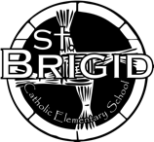St. Brigid Catholic Elementary School
Confirmation of Daily Covid-19 Student Screening Log

Parents/guardians/students must complete the Ontario School Screening Tool each morning prior to or upon arrival for each student. Confirmation of the daily screening must be provided to the classroom teacher upon entry into the school.
Student Name: ________________________________________ Class: ___________________
(Please Print)

Parent/Guardian Name: ________________________________ Date: _______________
(Please Print)

Verify in writing: |  | Verify electronically:  https://covid-19.ontario.ca/school-screening/  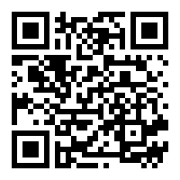  Students may alternatively complete screening on their own device, where age appropriate, and present on arrival.
I/we confirm the student (above) received a “pass” on the COVID School Screening Tool.
______________________________________________
Parent/Guardian Name (Print)

______________________________________________
Parent/Guardian Signature
Please initial each morning prior to attending school.
By initialing below, I/we confirm the Ontario COVID-19 School Screening has been completed for my child and my child has passed the screening.

Date | Parent/guardian initials
Monday January 3, 2022
Tuesday January 4, 2022
Wednesday January 5, 2022
Thursday January 6, 2022
Friday January 7, 2022
Monday January 10, 2022
Tuesday January 11, 2022
Wednesday January 12, 2022
Thursday January 13, 2022
Friday January 14, 2022

