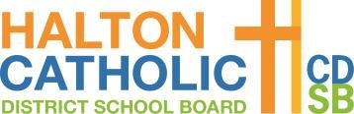

St. Brigid PA Day
Thursday September 2, 2021
9:00am – 3:30pm
Via Teams

Welcome & Prayer

School-based Priorities Logistics & Planning
Staff One Note
Schedules
Emergency Response Plan
St. Brigid Return to School Plan

Break

Meeting the Needs of all Learners: Learning Recovery and Intervention Strategies
Every Kid Deserves a Champion (https://www.youtube.com/watch?v=SFnMTHhKdkw)
Re-engaging the Learner
Expectations for Teaching and Learning

Culturally Responsive Pedagogy

Lunch

Culturally Responsive Pedagogy

Safe Schools Training - complete outstanding training on the OLS

Grade Level Planning
Mental Health
Literacy
Numeracy
D2L

