Meeting Information:
Date | January 6, 2020
Time & Location | 6:30-8:00pm, St. Bernadette’s Library
Attendees | Julie Riesberry | Marissa Pitt | Christine Phillips | Bruna Mancuso | Kim Sibley
 | Kirsten Sears | Holly DeRoia | James McAskill | Derota Roberts | Noreen Shallow
 | Dale Rosha | Chantall Phillips | Chantal Kelly-Neven
Regrets | Diana Palalas | Agata Stelmach | Christine Joncas | Ricardo Marques | Diane Tassone
 | Christine Csordas | Amanda Bitondo | Kelly Sanford | Elle Riva | Kathy Ventresca
 | Ljubica Krpan | Dora Magambi
Visitors
Next Meeting Date | February 3, 2020

Minutes:
1 | Welcome and Prayer | Christine and Bruna began with the opening Catholic School Council Prayer.
2 | Approval of Agenda | Christine asking the council if they have an agenda and if there are items to add as the events calendar change each meeting. The agenda was approved by James McAskill and seconded by Dorota Roberts. The goal to keep the meeting to the agenda items and if council members would like to have an item for discussion added to please email Christine and Bruna a week ahead. This would be helpful as there may be a need to wrap up a topic and move on to the next topic in the meeting.
3 | Approval of November 4 Meeting Minutes | The November 4, 2019 minutes were approved by Kim Sibley and Chantal Phillips to seconded the approval.
4 | Principal Report Update - Believing, Achieving, and Belonging
 | 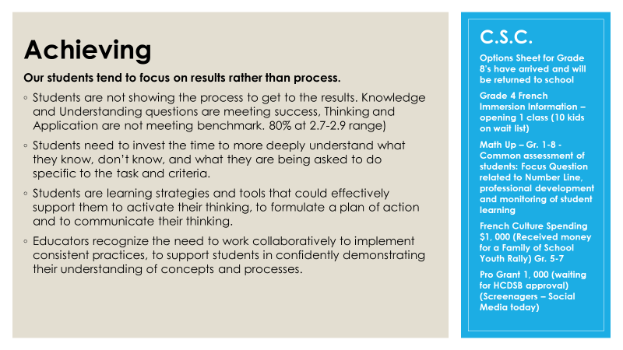
 | 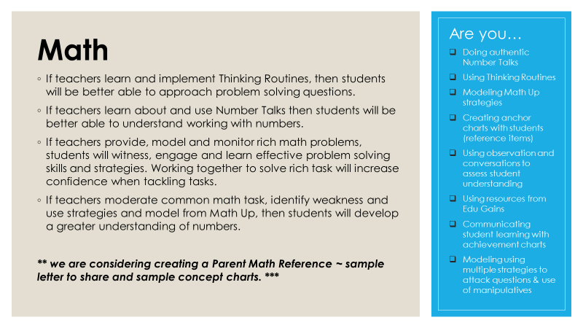
 | 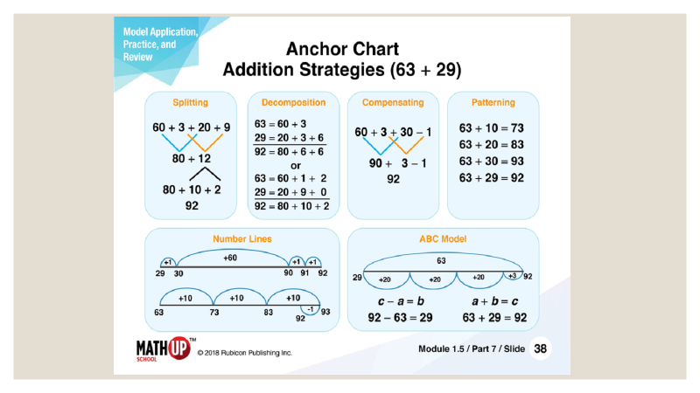
 | 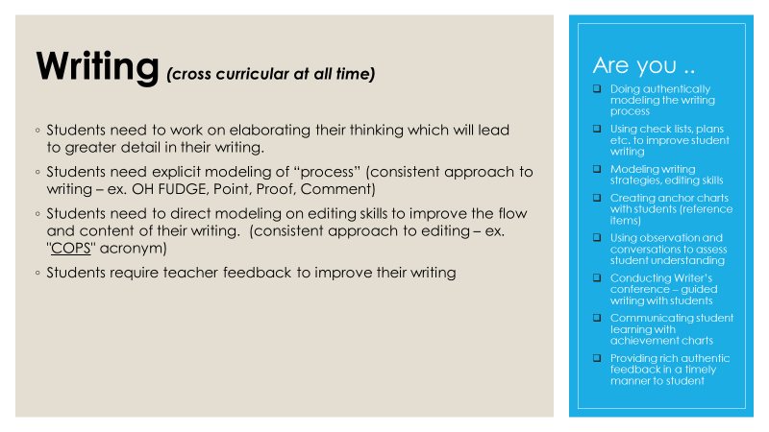
 | 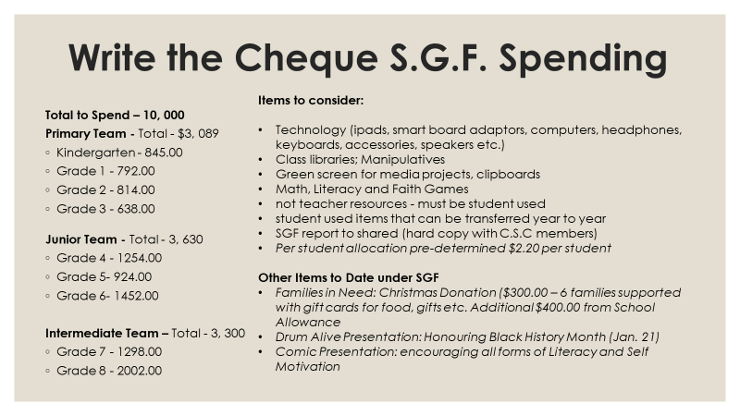
 | Update from Mrs. Riesberry | The feedback from the Gingerbread Family Night and Joy Day events were very positive. Art activity for class to do for decorating the gym. Choir singing and band play at a certain time.  The council discussed how the Gingerbread Family night was easy to run and wonderful for the community. Gingerbread night considerations: would like to network more with other families although parents did enjoy bonding with their own family. Council agreed and is interested in promoting networking among families. Further discussion for suggestions to promote the events for future years. Perhaps if have a large table to more families to fit in together, arrangement of tables to be discussed and considered. Interaction among families.  Mrs. Riesberry indicated the Work to rule and asking council to continue to provide the community with accurate messaging as outlined from school to support smooth information on what will be the process. The important to understanding all of the ways to look at the process and parents will be posted. If anyone has a question to forward parent to Mrs. Riesberry.  Address to council to support -Mrs. Riesberry talked about talking directly to the source and always available and have a conversation since teaching students to be authentic and genuine in communication so would like to role model that for our children/students. Makes for a healthy working and learning environment for all to have any questions/comments/concerns addressed directly and students learn how to address conflict in a healthy manner.  Parents indicated liked the Math sheet and suggestions about ways that parents can support their children at home with understanding the language used by teachers
20 | Safe, Equitable, Inclusive | 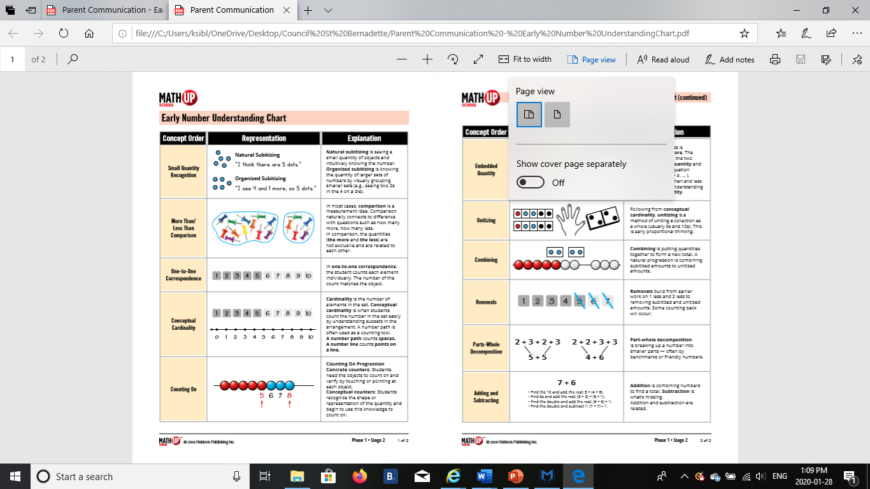
Overall Goal: Creating a positive school climate that supports a safe learning and teaching environment in which every student can reach his/her God given potential. Inclusive will only be accepted on school property, at school-related activities, on school buses, or in any other circumstances (e.g., online).

School Specific Goal(s):
- Strive to address student engagement through differentiated learning in the classroom and through varied leadership and participation-based initiatives during the school day and year. (focus on catholic graduate expectation development, building of self-esteem, empathy, and problem-solving)
- While focusing on prevention and working with families and the community, strive to ensure that a progressive discipline approach is utilized and is considerate of the varied mitigating factors which our students are Faced with and experienced.

Assessment and Informed, Collected Data | Training Strategies & Resources for School Climate and Inclusive | Prevention and Awareness-Raising Strategies for a Positive & Inclusive School Climate | Support Strategies for Positive School Climate | Communication and Outreach Strategies regarding School Climate and Inclusive | Responsibilities  and  Actions | Monitoring and Review Process (Include Timelines)
- School Survey: Learning Skills Data  - Incident Forms  - Special Education Data  - School Climate  - Suspension data  - Ongoing Staff Monitoring and discussion  - Catholic Council Goals  - Office Referrals School  - Specific Incidents  - Achievement Data  - Inclusive – Safe Teams  - Consultation Information collected from various community partners and agencies  - Student Voice | - Reporting & Responding Reports  - Whole school approach  - Staff professional learning  - Conferences/Workshops  - Board Training  - Initiative  - Police presentations on cyber-safety  - Public Health Resources  - Presentation Awareness  - Inclusive Awareness Week Activities  - Mental Health Presentations  - OGCE Framework  - Threat Assessment Training, First Aid/CPR Training  - Equity and Inclusion Training Opportunities  - Board Policy/Procedures | - Promotion of Mental Health/problem solving strategies  - Open communication between staff, students, and parents  - Modeling equitable and inclusive behavior and language  - Engagement of community supports / partners  - Evidence-based Inclusive Prevention Programs  - OGCE Character Education Initiative  - Code of Conduct assembly, agenda, announcements  - Teaching in the Classroom  - On-going Staff Training  - Mentorship/Modeling  - RAD - Recognition awards/assemblies  - BRAVO, Roots of Empathy, Friendship Program, PALS, Team Unbreakable  - Align supervision with needs assessment  - School-wide Progressive Discipline Plan  - School Plan to address violence, harassment, and inappropriate | - Timely, Sensitive, Proactive Response to all incidents and reports  - Accessing community supports  - Use of restorative practices  - Use of Progressive Discipline  - Mandatory reporting from all Board Employees  - Mandatory responding from staff that work directly with students  - Providing opportunity for improved behaviour  - Program modifications  - Behaviour and/or Safety plans where appropriate  - Daily/Weekly “Check-ins”  - Referral to a community partner for support | - Communicate policies, procedures and guidelines to all school staff, students, community stakeholders  - Website, Agenda, Weekly Memo, weekly Update  - Classroom ‘community’ discussions  - Catholic School School Council  - Staff Meetings  - Code of Conduct  - School Connects  - Community Engagement Nights  - Bully Awareness Week – Presentation & Activities  - Catholic Education Week | - Staff will engage  students, through teaching and  experiences, in developing  understanding around  our inclusive goals.  - Students will participate in the development of strategies which can be utilized to assist them in understanding what they need to do to be successful in meeting co-constructed goals  - Parents and Catholic Council will partnership with plan  - Schools Team will review School Survey data related to sense of belonging, bully-victim, and school safety measures on a yearly basis to help inform each school`s  - Inclusive Prevention and Intervention Plan.  - Review school emergency procedures on an annual basis | - Staff, Catholic Council SPTL’s, Student Ambassadors  - School Survey Data(4-8)  - Inclusive Incident data  - Leaning Skills data  - IEP Data  - Suspension data  - Number of incidents (pink slips to the office)  - Administration logs  - Office referrals due to student behaviour  - Targeting areas of need based on survey results  - Reviewing documentation practices and procedures
** working document

 | Council Chair Updates:
 | Uniform Swap | Chantal updated the council about the Uniform Swap. There was a good turn out, mostly primary/junior grade parents. There were about $300 made from the uniform swap and returned to the school. The committee received more uniform items than handed out (particularly received older McCarthy sweaters and pants). The Kindergarten exchange will take place during the Spring orientation day on April 6, 2020. Council members will be invited to attend the Kindergarten night to let parents know about the council and how to join and why we joined the council. There will be a council flyer for every new parent receiving the kindergarten package.
 | Review 2019-2020 Goal Setting | Christine will ask for circulated goals by email and good with the goals from last year - communication -succession planning, education strategies, social justice something to work on and embedded and think about next year
 | Event Calendar | Some highlights of discussion for future events are:  - Feb 25 – Shrove Tuesday – need to confirm the volunteers; Glenna and Bruna are the leads, connections with Longo to get supplies for the shrove Tuesday  - The Gingerbread event was very successful, earning $200 for Gingerbread event and families enjoyed the evening. Glenna provided and update on the on the event.  - Bruna was the lead for Angel Tree and there will be a new lead needed for 2021-2022 school year  Some tasks are:  -cut angels  -setting the tree  -organize the gifts  -bring the gifts to the church  -volunteers sign up and delegated based on jobs  -this is an event that really would be emphasized to all incoming parents and help in the set up  -teachers may also do community work in their classrooms and student ambassadors also run the food drive at the same time
 | Upcoming Events
- Family Skate Night in the evening; Glen Abbey location - Thursday April 23; we are not able to sell hot chocolate or cookies; free skate; find out about the concession stand; skate rentals; board is paying for the ice; Loyola can not bring popcorn because concession stand there at the arena
- Spring Concert during the day -tentative for during the day
- Cross Country – interschool sport – April 21
- Sacramental Lunch – May 26, 2020 - Bruna to share information for the lead
- BBQ – need activity – James would lie list to organize – June 10, 2020
- Grade 8 Graduation – June 18 -Mass in the day and dinner in evening
- June 10 -Bruna talked about Playday activity to support – council agreed to combine games at the school BBQ. Julie will look into whether or not the Ambassadors can assist at the event. Kirsten Sears is going to lead of the play day at the BBQ, volunteers will be needed; Glenna has a list of general volunteers
 | Closing Prayer
 | - Closing Prayer | Mrs. Riesberry lead the final prayer to close the meeting at 8:00 pm.
 | Future Council Meeting Dates
 | - February 3rd, 2020  - March 9th, 2020  - May 11th, 2020  - June 1st, 2020 | No meeting in April.

