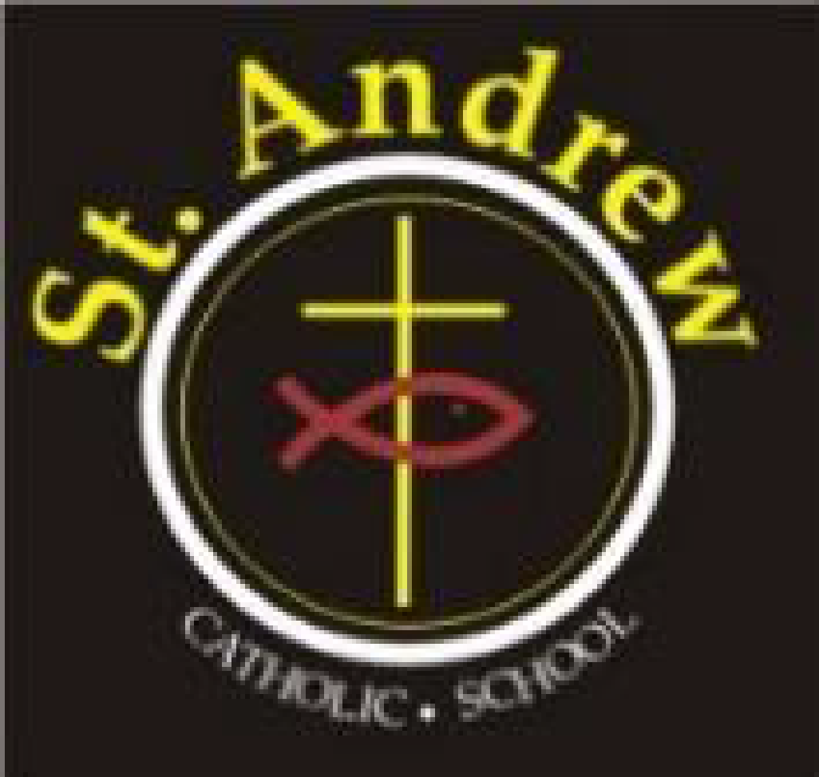
St. Andrew Catholic School Council Meeting
Wednesday, April 28, 2021 at 6:30 p.m.
Via Teams

Agenda

- Greetings & Opening Prayer 2 minutes
- Brief Administrator’s Update: Mrs. Boulos/ Mrs. Kotulak 15 minutes

- Committee Updates: 15 minutes
  - Cookbook Order Update
  - Communications – Laura
  - Parish Update – Marion
- Business arising from last meeting: 10 minutes
- Blaze pizza
- Indigenous Virtual Art Night

- New business for future meetings
_ Sarah Furlong 5 minutes
- Closing Prayer and Adjournment 2 minutes

Next meeting June 9, 2021 at 6:30 p.m.
Stay Safe

