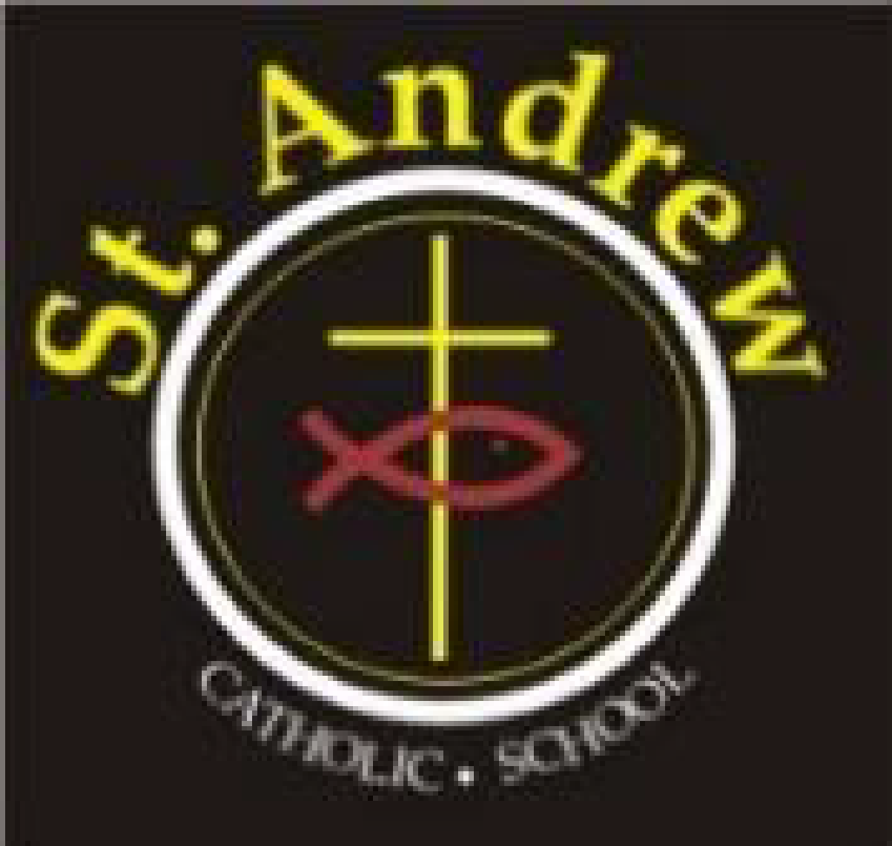
St. Andrew Catholic School Council Meeting
Wednesday, March 24, 2021 at 6:30 p.m.
Via Teams

Council members in attendance: Lorraine Boulos (Principal), Michelle Kotulak (Vice Principal), Christine Krueger (Chair), Kelly Williams (Parent Rep), Laura Gallo (OAPSCE Rep), Sonia Lancione (Parent Rep and Secretary), Emilia De Simone (Parent Rep and Treasurer), Nancy Harrison (Teacher Rep), Abi Adekitan (Parent Rep), Tolulope Adegbite, Crystal Duggan (Parent Rep)
Regrets: Richard Selwyn (Parent Rep), Latifah Thompson (Parent Rep), Sawsan Selwyn (Parent Rep), Patricia Nadal Droog (Support Staff Rep), Marion Bastiampillai (Parish Rep)
- Greetings & opening prayer: Meeting began at 6:36

- Approval of agenda: Approved by Kelly Williams, seconded by Laura Gallo
- Administrator’s report: Mrs. Boulos/ Mrs. Kotulak
  - Lent School Liturgy– Stations of the cross will be done together on Holy Thursday and students have submitted artwork to support the virtual event.
  - 24 hour fast – Intermediate students – some fasting with food and others with their electronics.
  - Confirmation – Live streamed from the church.
  - First Communion – open for registration on the MMOG website. Reconciliation must be done first
  - Children’s Liturgy Videos – available via MMOG website.
  - Job action – Teachers will not participate in staff meetings or professional development, otherwise they will be tending to the children and all their needs without impact.
  - Online students returning to classes – numbers were low enough to have no impact to classes. This was the last time students will be returning to in-class from online.
  - Field trips – all have been virtual this year. School negotiated flat fees per class.
  - Covid cases in the school – first case was not in the school when contagious. Second case lead to a class being closed and no other cases resulted from it. Last 2 cases also closed the classes.
  - Touchless hand dryers – school received an email stating they were selected to receive touchless hand dryers over the course of the summer.
  - Kindergarten registration – Numbers are down.
  - Catholic education week – Walk with Jesus will be virtual, cross making activity with natural materials.
  - Grade 8 graduation – Will order lawn signs again this year for drive-thru grad. Students are scheduled to get photos done at Edge Imaging studios. Photos can be on the signs. Virtual students will be included in the virtual events and graduation book. They will be included in all the awards except academic. Those will also be done separately in a virtual celebration.
    - Emilia raised a motion for council to approve the cost of the balloon arches( approx. $200), lawn signs (approx. $945), grad awards (approx. $1,000) and swag bag (approx. $2200) all to come from council budget – majority in favour – motion passed.

- Council budget update: Emilia
- Easter crafts – used for kindergarten kids
- Confirmation retreat – covered
- Goal ball – grade 4 class got try out this team sport specifically designed for visually impaired athletes
- More Chrome books purchased for the school
- Virtual field trips for several classes – covered
- Parent engagement – Kahoot expense (offset by nominal fee charged), online gingerbread baking expense also included
- Overall remaining funds are lower than usual, but we’re still in good shape going into next year.

- Committee updates:
  - Cookbook (Kelly Williams)- It turned out to be 99 pages of recipes! Pages are mainly black and white with 16 pages of assorted photos in colour. Chose the printing house to execute. Cost should mostly be covered by purchase price set for families to buy. Price to be set for $20 per book. Orders will be set up in advance of printing through cash-online. Kelly to create a marketing poster for Lorraine to print and put up in the school.
  - Communications (Laura Gallo) –Last newsletter was sent out in March. Next one set for April 1. Will include mental health info, summer camp links, cookbook info and more. Ideas for May to include mother’s day emphasis and June emphasis on father’s day.

- Business arising from last meeting:
- BBQ: Kelly - we’re confirmed that we will not have a BBQ this year. Once we confirm the date for next year, we will secure the vendors. Will consider hiring BBQ brothers possibly for curriculum night in the fall if we’re able to gather safely.
- Fund raising ideas: Christine raised the idea of partnering with a small business to offer a “meal deal” for our school families and the school receives a small percentage back from the proceeds. Council members will look into pizza, pastries and pasta.
- Virtual Parent Engagement Ideas:
  - Virtual Indigenous art paint night. Would need to figure out the logistics for paints and canvas. Targeting May 5 (Sugar Moon, representing the maple syrup), Lorraine will investigate.
  - Virtual Cooking – this was very successful in December. Lorraine to connect with previous vendor for more info on options.

- New business for future meetings: Virtual parent engagement night, cookbook, update on grade 8 grad plans,

- Closing prayer and adjournment: meeting adjourned at 8:01

Next meeting April 28, 2021 at 6:30 p.m.

