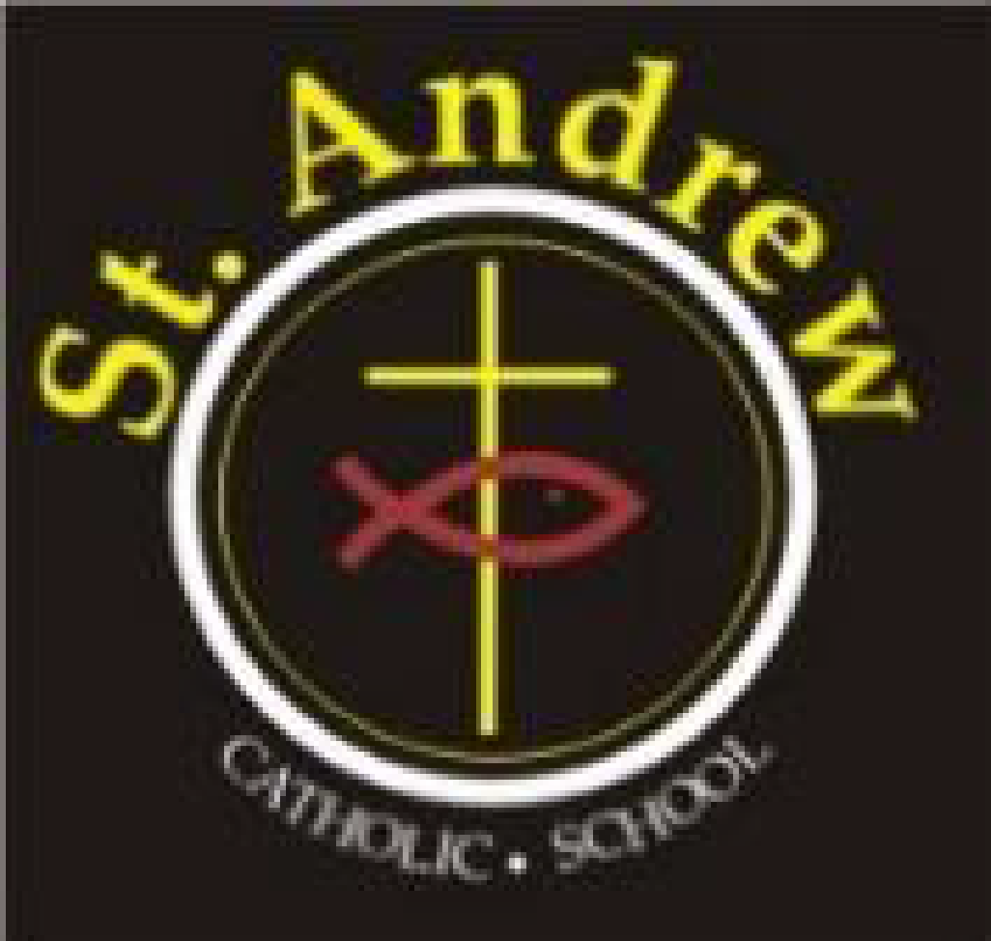
St. Andrew Catholic School Council Meeting
Wednesday, April 28, 2021 at 6:30 p.m.
Via Teams

Council members in attendance: Lorraine Boulos (Principal), Michelle Kotulak (Vice Principal), Christine Krueger (Chair), Kelly Williams (Parent Rep), Laura Gallo (OAPSCE Rep), Sonia Lancione (Parent Rep and Secretary), Emilia De Simone (Parent Rep and Treasurer), Nancy Harrison (Teacher Rep), Abi Adekitan (Parent Rep), Tolulope Adegbite, Crystal Duggan (Parent Rep), Marion Bastiampillai (Parish Rep); Latifah Thompson (Parent Rep)
Regrets: Richard Selwyn (Parent Rep), Sawsan Selwyn (Parent Rep), Patricia Nadal Droog (Support Staff Rep)
- Greetings & opening prayer: Meeting began at 6:34

- Approval of agenda:
  - Approved by Kelly Williams, seconded by Emilia De Simone
- Administrator’s report: Mrs. Boulos/ Mrs. Kotulak

- See appendix attached for the full report.

- Committee updates:

  - Cookbook Order Update:
    - Initial orders are in and emails have been sent out to remind those that have submitted a recipe.
    - Pick-up will be at the school – targeting mid-June
    - Cut-off for orders is June 1

  - Cookie orders update:
    - Sales are good, lots of re-orders – THE COOKIES ARE AMAZING!
    - Last day to order: May 3

  - Communications (Laura):
    - Preparing the May newsletter – selecting 3-4 top ideas to communicate

  - Parish Update (Marion)
    - Father Jerry Punnassery, CMI will be installed by Auxiliary Bishop Wayne Lobsinger as the new Pastor at Mary Mother of God Parish on Sunday the 2nd of May at the 11:00 am mass. Father Jerry is from the order of Carmelites of Mary Immaculate (CMI).

- Business arising from last meeting:
  - Blaze Pizza – fundraiser on June 16
  - Indigenous Virtual Arts Night – council decided not to go ahead

- New business for future meetings:
  - Sarah Furlong – invite to our next meeting to discuss presenting to families virtually about social media.
  - Pride month planning
  - Curriculum night discussion – likely the second or third Thursday in September. Potential to incorporate a BBQ with it.

- Closing prayer and adjournment: meeting adjourned at 7:35

Next meeting June 9, 2021 at 6:30 p.m.

St. Andrew School Council Meeting
Administrators’ Report for April 28, 2021

Item | Information
Catholicity | Currently in Easter Season  - Stations of the Cross were done virtually  Catholic Education Week  - Next week is Catholic Education Week – teachers will be sharing on their platforms any activities that are planned.  - Walk With Jesus – families will be invited to participate, live stream at 10:00 on Thursday, link on school and Board website  - First Reconciliation/First Communion postponed  - New Pastor at MMOG – Father Issac is returning to India this week. We welcome a new Pastor, Fr. Jerry Punnassery  - Potential Grad Mass – Debbie Frey will ask Fr. Jerry if he is able to host a livestreamed Grad Mass for us
Curriculum | Online Learning – at this point, no end date has been given. Things are going well, smoother transition this time than in January. Approximately 115 devices given out for this period with another 50 or so that were given out to the Virtual Students  - School is open to students with complex needs who cannot access learning virtually  Gifted Program  - Gifted Open House took place April 19th  Kindergarten  - Orientation Q and A took place on April 22nd – very small turnout  Classroom Organization  - We will shortly begin the task of making up new classes for next year. As always, we can expect changes to teaching assignments, so we don’t encourage parents to request specific teachers.  Grade 8 Graduation  - Transition planning for Secondary school is ongoing for our Grade 8 Students  - Planning for our Grade 8 Graduation has begun  Intervention Programs  - Mr. Giorgio and Mrs. Thompson continue to run Literacy/Numeracy support for our Intermediate students on Tuesdays/Thursdays after school  Student Awards of Excellence  - Student Awards of Excellence Evening will not take place this year. There will be a Feature Story on our website for our Award winner – Erica Brohman  Spirit of Inclusion Award  - Our Spirit of Inclusion Award winner this year is Gabriella Fuoco – she will be included in the same Feature Story
Culture and Community | Health and Wellness  - Virtual Mental Health webinars continue to run in the evenings  Equity and Inclusion  - Our Friday PA Day was about Equity and Inclusion with an introduction to our new board document Responding to Racism with Faith, Hope and Love.  Kindergarten Playground  - Will be getting a refresh over the summer  Pride Month

