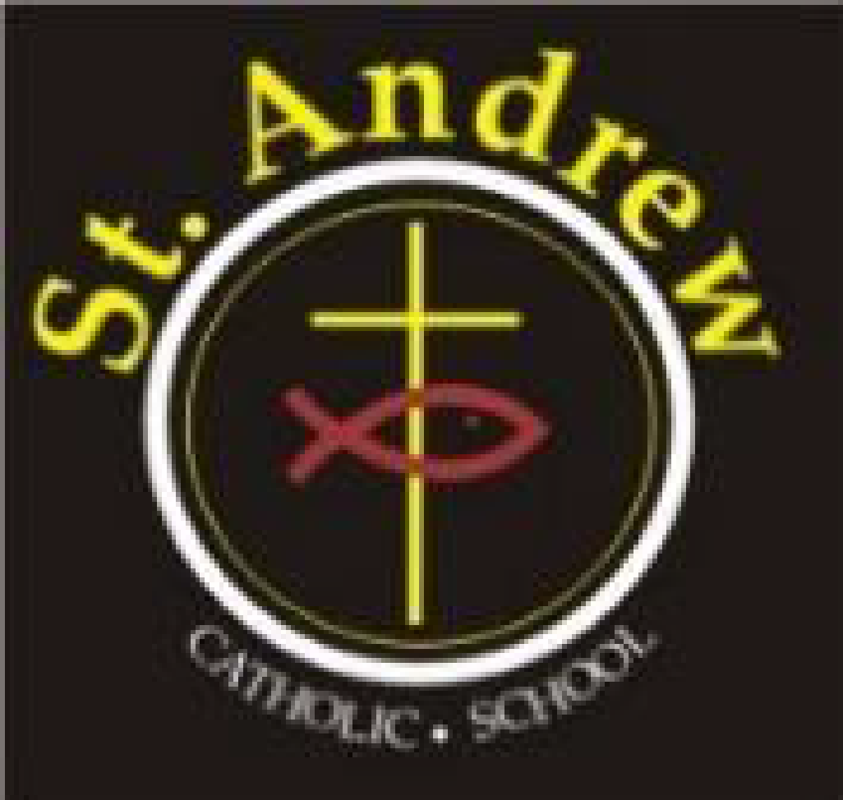
St. Andrew Catholic School Council Meeting
Wednesday, March 24, 2021 at 6:30 p.m.
Via Teams

Agenda

- Greetings & Opening Prayer 2 minutes
- Administrator’s Report: Mrs. Boulos/ Mrs. Kotulak 30 minutes
- Council Budget Update- Emilia 10 minutes

- Committee Updates: 20 minutes
  - Cookbook- Christine/Kelly
  - Communications – Laura
- Business arising from last meeting: 20 minutes
- BBQ: Kelly and deposit
- Fundraising ideas – Blaze pizza
- One More Virtual Parent Engagement night?

- New business for future meetings 5 minutes
- Closing Prayer and Adjournment 2 minutes

Next meeting April 28, 2021 at 6:30 p.m.

