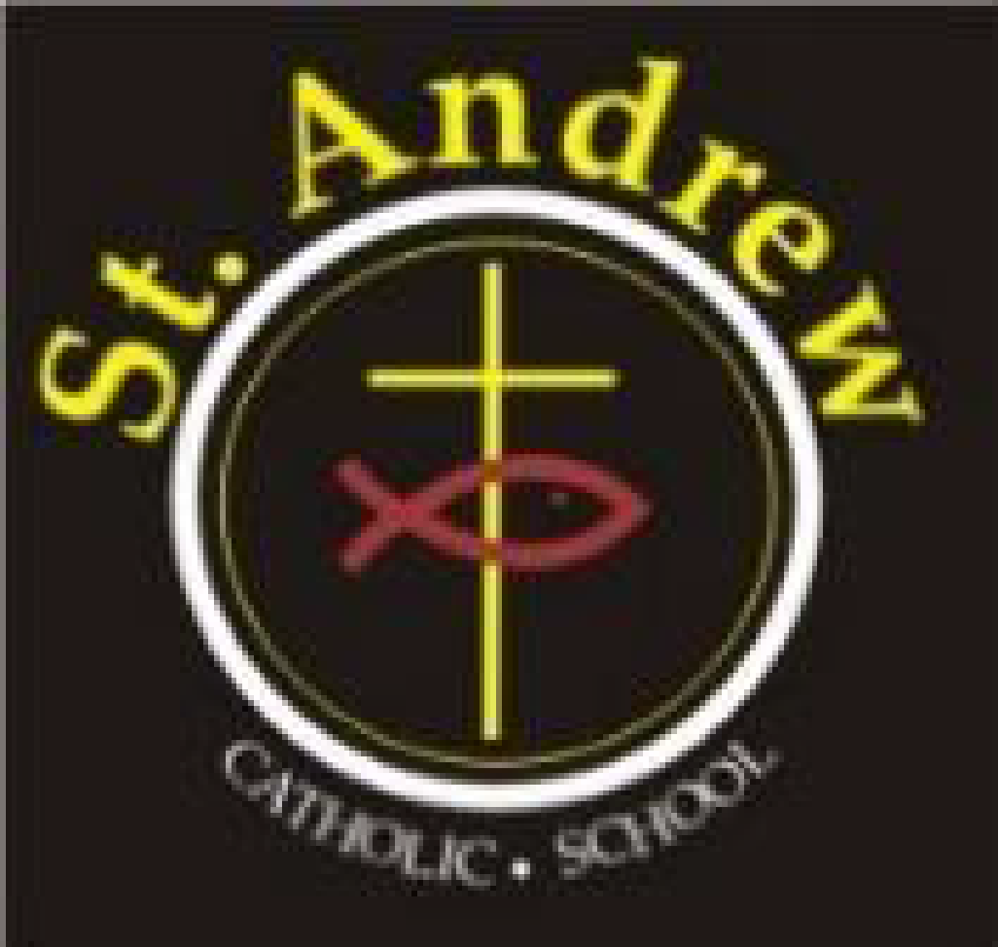
St. Andrew Catholic School Council Meeting
Wednesday, January 20, 2021 at 6:30 p.m.
Via Teams

Council members in attendance: Lorraine Boulos (Principal), Michelle Kotulak (Vice Principal), Christine Krueger (Chair), Kelly Williams (Parent Rep), Marion Bastiampillai (Parish Rep), Laura Gallo (OAPSCE Rep), Sonia Lancione (Parent Rep and Secretary), Emilia De Simone (Parent Rep and Treasurer), Sawsan Selwyn, Patricia Nadal Droog (Support Staff Rep), Nancy Harrison (Teacher Rep), Abi Adekitan (Parent Rep), Tolulope Adegbite, Crystal Duggan (Parent Rep),
Regrets: Richard Selwyn (Parent Rep), Latifah Thompson (Parent Rep)

- Greetings & Opening Prayer: Meeting began at 6:36

- Approval of agenda: Approved by Sawsan Selwyn
- Administrator’s Report: Mrs. Boulos/ Mrs. Kotulak
  - Online learning has been extended for Halton until at least Feb 10. Dependent on whether number of cases go down.
  - Confirmations and communions require parents to contact the church and register their children. Confirmation retreat will happen this year. Communion parents, if you received the email with a video message, your prior registration was successful.
  - Joy day was a success! All classes had a pizza / PJ day and had the teacher hand out the pizza
  - Ash Wednesday liturgy
  - Jan 27 – Holocaust liturgy (primary, junior and intermediate versions)
  - Curriculum – literacy and numeracy programs will be run virtually for grades 7 & 8
  - Friday Feb 5 – PA day – report card writing day.
  - Report cards coming out Feb 24
  - Culture & Community – virtual bake night went very well. Hope to do it again regardless of a pandemic
  - Conduct assembly – will review all policies again once the kids return to school. Biggest change will require the kids to wear their masks outside.
  - Spirit wear – online store will be reopening soon
  - Halton food for thought – provided snack boxes in lieu of breakfast club. We have permission to use our excess funds to turn into gift cards to support our families in need.
  - Kindergarten registration – JKs registered this year are very low to-date.
  - COVID Testing protocol – all we know if that there will be testing protocols, but we don’t yet know if we will be involved and what it will look like.
  - 7 new registrations and 13 requests to return face-to-face. Returns have been delayed until we’re back in person.

- By-laws/Board Policy: Christine
  - Parent councils have a specific composition (Procedure No. VI-84) requirement from the Board where the majority must be made up of Catholic parents (only 2 are allowed to be non-Catholic), however CPIC may be looking to further clarify the role requirements. CPIC asked all councils for feedback
  - Feedback was heard that council agree the majority should be Catholic, however, 2 non-Catholic members were thought to be too few. Perhaps a percentage of the total number rather than an actual number would be considered.
  - On a separate issue, our Council is proposing to amend its by-laws to an increase in members by 2 (from 12 to 14).
  - Sawsan Selwyn moved to Amend articles 3 and 14 of the St Andrew bylaws in the form that was presented to Council – Kelly Williams seconded the motion. All were in favour.

- Council Budget Update: Emilia
- Discussed in past meetings that we will use some excess funds to purchase more devices for students. Devices do not include iPads.
- Clarified that the iPads and apps are managed by the board and run by their IT dept. Boards purchase the apps in bulk and put them in a catalog for iPad users to select from. iPads are managed by IT through AirWatch so anything manually uploaded from the app store will be wiped after 48 hrs.

- Committee Updates:
  - Cookbook- Members Richard, Sawsan, Latifa, Christine – don’t have many recipes yet. Hoping to have the communication committee draft up a blurb teachers can paste up on their online class posts and get the students excited about it.
  - Communications – Members Laura, Christine, Emilia, Abi, Trish, Sonia – 1st Newsletter was sent out
  - Parish Update – Marion:
    - 25th anniversary of MMOG coming up.
    - Children’s liturgy videos are amazing!
    - Masses are all live streamed now
    - Youth mass happening once a month – last one was beautiful and the kids had a great time.

- Business arising from last meeting:
- BBQ: Kelly - we’re in a wait and see holding pattern. We will table this update again at the next meeting.
- Virtual Parent Engagement Ideas: Feb 25th Kahoot night or similar, 7pm, “How well do you know St Andrews school.” Charge an event fee of $2 via cash online, order prizes (family games), part of funds will go towards helping the community.

- New business for future meetings: year-end celebration ideas

- Closing Prayer and Adjournment: meeting adjourned at 8:35

Next meeting March 24, 2021 at 6:30 p.m.

