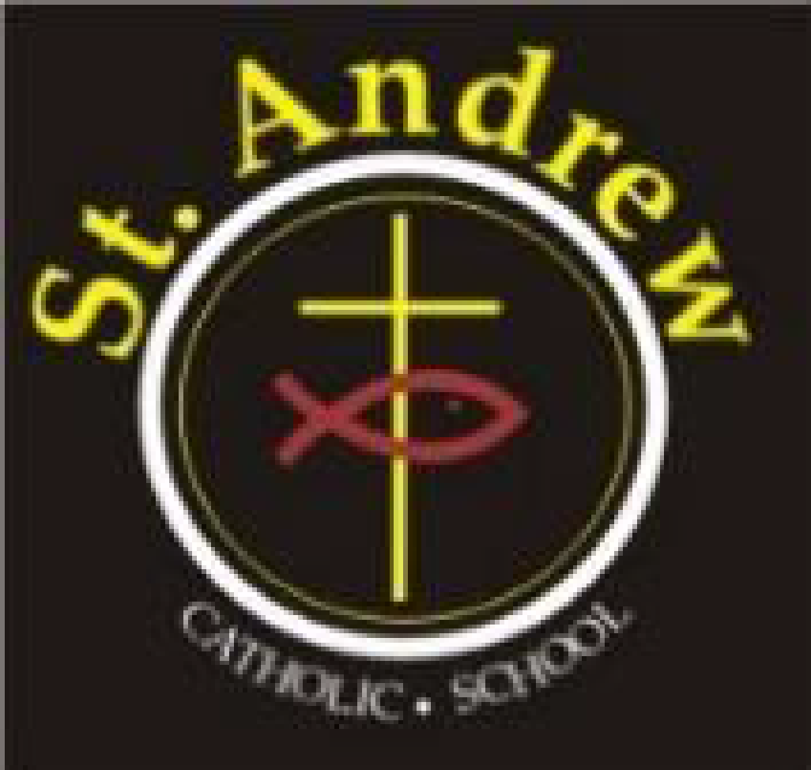
St. Andrew Catholic School Council Meeting Minutes
Wednesday, November 18, 2020 at 6:30 p.m.
Via Teams

Council members in attendance: Lorraine Boulos (Principal), Michelle Kotulak (Vice Principal), Christine Krueger (Chair), Kelly Williams (Parent Rep), Marion Bastiampillai (Parish Rep), Laura Gallo (OAPSCE Rep), Sonia Lancione (Parent Rep and Secretary), Emilia De Simone (Parent Rep and Treasurer), Crystal Duggan (Parent Rep), Abi Adekitan (Parent Rep), Richard Selwyn (Parent Rep), Sawsan Selwyn Latifah Thompson (Parent Rep), Patricia Nadal Droog (Support Staff Rep), Nancy Harrison (Teacher Rep)
Regrets: None
- Greetings & Opening Prayer
  - Meeting began at 6:35

- Approval of Agenda
- Approved by: Sawson Selwyn & Laura Gallo
- Halloween Boogie-a-thon results/wrap up
  - Raised $16,131!
  - Loot bags were a big hit
  - Winning classes were based on percentage of class participation this year

- Council Budget Update: Emilia
  - Various expenses are expected to be lower this year, therefore; it was proposed to allocate a greater amount of money to curriculum
    - Budget approved unanimously
    - Note: Re: June BBQ, Kelly Williams to look into the cancellation date deadlines with BBQ Brothers and Main Event to see when we need to make the go/no go decision.

- Principal’s Report: Mrs. Boulos/ Mrs. Kotulak
  - Presented by Lorraine Boulos
  - Progress reports going home electronically on Nov 24 Make sure you download it and save it because the link expires.
  - Parent teacher interviews will be virtual by phone, MS Teams or Google Meet
  - 202 students learning virtually in 18 different classrooms. Only 4 of our virtual teachers actually have St Andrews students in their class.
  - Math-up – new resource this year – working really well
  - Looking to make school more fun with fun Fridays for both in-school and virtual to participate
  - In lieu of breakfast club, food boxes full of snacks have been provided for each class
  - Equity and inclusion plan is in focus for this year
  - New single Covid case came up today – not due to transmission in the school
  - Asking for parents help and support in maintaining social distancing outside of school
  - Kids are now wearing their masks on their way out to recess. They only come off as they walk out the door after sanitizing their hands.
  - Lockers are on a colour coded system so kids aren’t next to one another when they access them
  - New protocol for late arrivals. Line ups for late slips are outside to avoid mixing cohorts. Attendance is taken in class at 9:05. Kids need to get a late slip because only the office have the capability to update the attendance status from absent to present.

- Parish Update – Marion
  - 101 families/151 children in our neighbourhood who need our help through the St Vincent de Paul Society
  - No tree this year, instead, donations from our school will be used to buy gift cards in bulk for each of the families
  - The peace light from Bethlehem is coming to MMOG. https://mmogp.ca/peace-light-from-bethlehem
  - 7 masses will be set up at MMOG as well as an online mass. In person masses will require registration prior to Dec 24/25
  - Next year is MMOG’s 25 year anniversary!

- Uniforms –review / dress code committee / consultation
  - Policy change this year, beginning in January 2021
  - Uniform provider will need to have a program in place for families requiring financial support
  - New policy does not require uniform bottoms to be purchased from the uniform provider
  - Every 3 years we need a committee in place to decide whether we take this to a vote or defer (we are at our 3 year mark now)–
    - our committee unanimously agreed to defer the uniform vote at this time

- Business arising from last meeting:
- by-law review around the number of members on school council. Christine will update the bylaws and present at the next meeting
- fundraising committee – cookbook – Lorraine will raise it at the next staff meeting.
  - Members interested in participating the cookbook subcommittee: Richard Selwyn (co-lead), Christine Krueger (co-lead) , Tolu Adegbite, Obi, Kelly Williams, Latifat Thompson, Sawsan Selwyn, Patricia Droog, Marion Bastiampillai, Victoria Rodrigues
- communications committee –newsletter & email - no dedicated website at this time.
  - Members interested in participating in the newsletter subcommittee: Laura Gallo (lead), Christine Krueger (email holder), Sonia Lancione, Abi Adekitan, Patricia Droog, Richard Selwyn

- New business for future meetings:
- Special meeting scheduled for December 16, 2020
- Closing Prayer and Adjournment:
  - Meeting adjourned at 8:47pm

Next Regular Meeting January 20, 2021

Administrators’ Report
Item | Information
Catholicity | - Remembrance Day Celebration November 11th hosted by our Grade 3 students – we used YouTube  - We are asking families to donate once again to the SVDP society but via online donations rather than gift cards  - Light in a Barn  - First Communions have taken place for our students who missed it last year  - First Communion/First Reconciliation and Confirmation for our Grade 2 and 7 students – parents need to register online this year directly with the church
Curriculum | Teaching and Learning during a Pandemic  - There are a series of workshops online for teachers provided by the board on how to teach when social distancing is in place  - Progress reports of ALL St. Andrew students are being read by Mrs. Kotulak and Mrs. Boulos  - Progress Reports will be going home electronically on November 24th  - Students who moved on October 19th – their reports will be written by the teacher they were with as of the 19th  - Learning Conferences – will be taking place on November 26th and 27th  - Parents have to sign up online using link provided. Interviews can take place via Teams, Google Meet or telephone conversation  - We have just updated our licenses for Lexia  - We purchased RAZ Kids licenses for all Grade 1 and 2 students  - Working on strategies to keep Virtual students connected – we have 18 different virtual teachers teaching 202 of our students  - New Math resource is going well  - Grade 4 Gifted Screening for F2F and Online students
School Climate | School Spirit  - Fun Fridays - Crazy Hat Day  - School Spirit Wear  - Scholastic Book Fair – happening virtually  Nutrition Programs  - Grab and Go Snack boxes in each class from Halton Food for Thought  Mental Health and Wellness  - Ms. Ryrie, our CYC, is not permitted to go into classrooms, so she is planning tailored lessons for some of our classrooms, for example: Kelso’s Choices in our Primary classes, and she is making them virtual  - Ms. Ryrie is organizing resources for teachers to use with students this week for Bullying Prevention  - We have instituted an Equity and Inclusion Action Plan with a specific goal to target Anti-black racism in our school.  - We are defining Racism as a system of advantage based on skin colour – this differs from discrimination, (which of course we also deal with) in that it is a system of racist policies and ideas that normalize racial inequalities.  - We plan to set up a system whereby staff, students and parents can report complaints of racism and discrimination and know that their concerns will be addressed
Safety | Lockdown and bomb drills –  - Will be taking place in November and December  Covid Protocols  - Second positive case today – class is closed, students are in isolation for two weeks, siblings can attend school  - Students are having more difficulty maintaining social distance, requiring regular reminders, many families are not following protocols – sleep overs, carpooling, playdates, etc.  - Pinnies are getting lost, so we are using stickers – much more cost-effective  - Lockers are opened now, careful protocols in place to avoid students congregating in hallways  New Protocols for students who arrive late to school
Fundraising | - Dance-a-thon –very successful, very positive feedback  - Grand total: $16, 000 (approximate)  - Many, many thanks to the numerous volunteers who helped to organize!
Staffing Update | - Mrs. Cox is on a leave and we are unsure of her return at this time, currently we have Mrs. Connell in the class.  - Mrs. Ambrozy is on a leave, she is expected to return right after the Christmas break, her LTO will be Mrs. Kontrec  - Mrs. Rosehart is on a leave, we are unsure of her return at this time, currently we have Mrs. Calvise in the class

