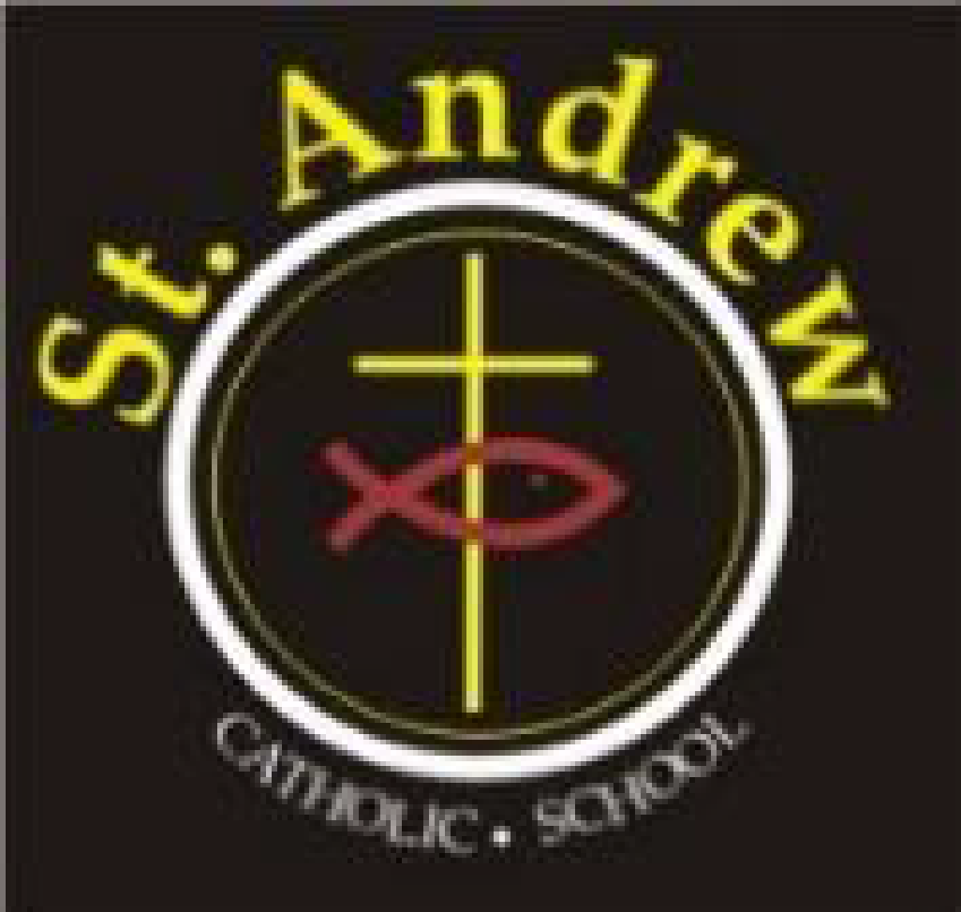
St. Andrew Catholic School Council Meeting
Wednesday, November 13, 2019, 6:30 p.m.
to 8:00 p.m. in Library

Agenda
- Greetings & Opening Prayer 2 minutes
- Approval of Agenda 2 minutes
- Halloween Boogie-a-Thon results/wrap-up
-discuss for next year the one ticket policy 10 minutes

- Administrator’s Report: Lorraine B/Elisa C 25 minutes

- Council Budget Update- Emilia 10 minutes
- Business Arising from last meeting 20 minutes
      - Update on Aussie X night – cancelled Oct. 17th
      - Parent Engagement Night – the Learning Tree for January 23rd
      - Wishlist for expenditures
      - BBQ Update (June 4) – Kelly
e. Bishop’s Dinner, November 6, 2019
f. Parish Update – Marion
g. Student Council Update (include if a SC rep is attending)

- Council of Chairs Meeting Oct. 16, 2019 10 minutes
-Child Learning Bond
-Pro Grant
-OAPCE

- Parent Council Newsletter / blast 5 minutes
- New business for future meetings 5 minutes
- Closing Prayer and Adjournment 1 minute
Next Meeting January 29, 2020 at 6:30 p.m.

