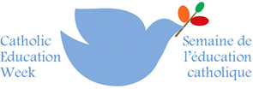
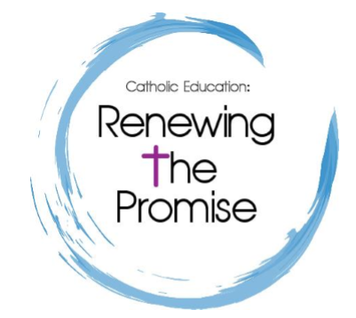

Catholic Education Week at St. Andrew

Dear Parents and Guardians,

Please join us as we celebrate Catholic Education Week. Our theme this year is “Living as Joyful Disciples”. This year, we will be exploring Joy in the Arts. We open our doors to invite you in and see Catholic Education in action with your child (ren), their peers, our community and staff.
Please see the schedule below for the joyful events that will be taking place at our school.

Monday May 6– Rooted in Prayer
Mrs. Mihalides’ Grade 3 class will be exploring the world of nature by painting owls. Parents are welcome to join the students and assist them in completing their painting at 1:00 pm on Monday room 208.
The students in Miss Burrows’ Grade 3 class will be exploring the connection between humans and animals through the artwork of Canadian Indigenous artist Norval Morrisseau. Parents are invited to paint with their children on Monday in room 117 at 1:00 pm.
Our Grade 4 classes will be participating in their Swim to Survive Program.
Tuesday May 7 – Living in Community
The future is all about living and working together in community. At St. Andrew, we encourage our students to be collaborative problem solvers able to work together to achieve a common good. We are very honoured to have the people from Intel and CDW spend the day with our Grade 5 students for a “STEM Day”. All of our Grade 5 students will work in teams to build mini-computers, install the operating systems, and program their computers to operate a robot. Parents of our Grade 5 students are welcome to come by the school and visit their children as they develop their technological skills any time during the day.

Wednesday May 8 – Doing Justice and Creating Hope
St. Andrew will be hosting an Art Gala on Wednesday evening at 6:30 pm. There will be several pieces of student artwork available for silent auction, all proceeds will go to a charity of our students’ choice to support the Arts. Dress is casual, refreshments will be served!

Thursday May 9 – Journeying Together in Faith
Please join us at 9:30 am for our own walk with Jesus through our neighbourhood displaying a sense of community and our Catholic faith. This is an excellent way to come together to celebrate the privilege of our Catholic Education.
Selected students from grades 6-8 will represent the students, staff and community of St Andrew at the HCDSB board-wide Walk with Jesus. All the schools in our board will have student representatives at this annual walk. Join the conversation on twitter tag #HCWWJ and follow @HCDSB.
Parents are invited to join their child(ren) on a tour of our “Good News Gallery”. This is an excellent opportunity to peek inside your child(ren)’s day and to learn from them. You cannot ask for a better teacher than your child. All the artwork on display has been influenced by themes in Catholic Education.
Class Schedule for the Good News Gallery Day 1
10:35 – 11:05 Mr. Tallevi and Mr. Maillet’ Grade 8 Classes
11:05 - 11:35 Mrs. Boyko’s and Mrs. Thompson’s Grade 8 Classes
12:55 – 1:25 Mrs. Young, Mrs. Wilkinson’s Grade 6 Classes
1:25 – 1:55 Mrs. Galluzzo’s and Mrs. Densmore’s Grade 4 Classes
2:00 – 2:30 Mrs. Bertin & Mrs. Eramo’s and Mrs. Harrison’s & Calaminici’s Kindergarten Classes
2:35-3:05 Miss. Medeiros’ Grade 6 Class
Ontario Children’s Author, Jodi Carmicheal, will be presenting to our Grade 5 students at 1:00 pm and to our Grade 6 students at 2:30 pm in the Learning Commons on Growing a Story. Parents are welcome to join their children during the presentation and learn along with them.
7:00 PM Parents of students who will be new to Kindergarten in September are invited to a Kindergarten Orientation Evening.

Friday May 10 - Sharing the Good News
Our Grade Two students will be heading to Mary Mother of God Parish for their Retreat in advance of their First Communion which will be taking place on Saturday. Parents are invited to meet their children at the church at 10:00 am.
Class Schedule for the Good News Gallery Day 2 :
9:05 – 9:35 Mrs. Twardawa’s and Mrs. Skilton’s Grade One Classes
9:35 – 10:05 Mrs. Rogulski’s Grade One Class
10:35 – 11:05 Mrs. Tilley’s Grade 4 Class and Mr. Giorgio’s Grade 6/7 Class
11:05 - 11:35 Mrs. Chorzepa’s Grade 7 Class and Mrs. Bowles’ Grade 7 Class
12:55 – 1:25 Mrs. Boyko’s and Mrs. Thompson’s Grade 8 Classes
1:25 – 1:55 Miss Penwarden’s and Mrs. Hazel-Stother’s Grade 3 Class
2:00 – 2:30 Mrs. Zeffiro’s & Mrs. Nisbet’s and Mrs. Deamone’s & Mrs. Landry’s Kindergarten Classes

