Class Placement 2017-2018
http://www.hcdsb.org
Click on the Schools tab- School Listing
Choose School--

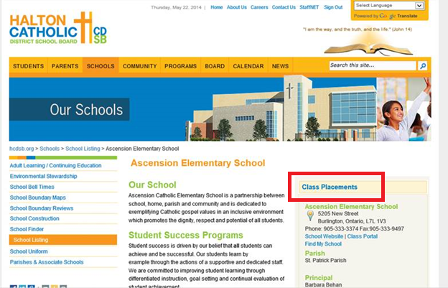

Click on Class Placements

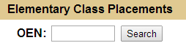
Enter OEN # and Click Search

