Dear Parents/Guardians,

Next week at OLF, we will have various Christmas activities during our Christmas Spirit Week. Please see the schedule below for our themed days. We look forward to seeing our staff and students enjoying these various themed spirit days.

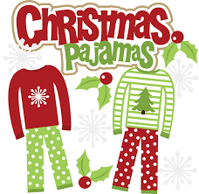
December 14th - Pajama Day (wear your favourite pajamas)

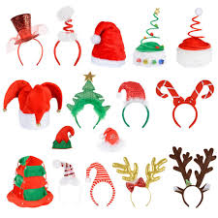
December 15th - Christmas Accessories/hat day (wear your favourite Christmas hat/toque or accessory)

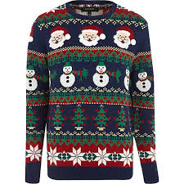
December 16th - Christmas sweater/shirt day (wear a Christmas themed or Red/Green shirt or sweater)

December 17th - Christmas Socks (show those Christmas socks off to everyone)
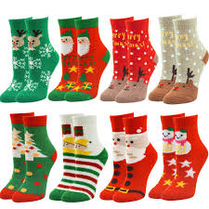

December 18th - Christmas Colours (the more Red, Green and White the better!)
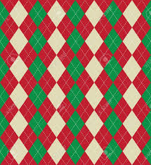

Thank you,

