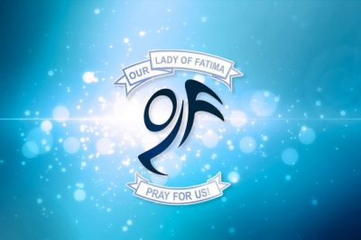

Catholic School Council

AGENDA
November 18, 2019 | Our Lady of Fatima Library | 6:30 pm

TOPIC | PRESENTER

Welcome and Prayer | Tonia Sgro-Madrick & John Babos
Introductions | All
Approval of agenda and minutes from previous meeting | Tonia Sgro-Madrick
X-Movement Presentation | Conor Dullard
Council of Chairs Meeting - Highlights | Rey Reyes
Parish Updates | Claudia Ianiro
PEACE Week Initiatives | Leanne Storey
Fundraising Updates  - Halloween Dance-a-thon  - Poinsettia Sales | Viviana Varano
Principal’s Report | Viviana Varano
Math Activities – Building Numerical Literacy | Vanessa Gear
Sub-Committees Updates - Advent liturgy and tree lighting ceremony  THURSDAY DECEMBER 5 @ 6:30PM IN OLF GYM  - Liturgy (Stable, student readers)  - Carol singing  - Tree Lighting (Set up of tree)  - Family portraits with Edge Imaging  - Refreshment (Candy Canes, juice boxes, cookies) | Tonia Sgro-Madrick
Action Items Recap | Secretary – Faye Aguiar
Adjournment | All

- Next Meeting – February 3, 2020 @ 6:30pm

