Holy Rosary (Milton)

CATHOLIC ELEMENTARY SCHOOL

HALTON CATHOLIC DISTRICT SCHOOL BOARD

2018-2019

|  |
| --- |
| ACHIEVING: Meeting the Needs of All Learners |
| 1. Curriculum driven Learning Goals and Success Criteria will guide instruction and assessment. 2. Educators will provide timely and specific Descriptive Feedback to advance Student Achievement. 3. Educators provide opportunities for Self-Assessment to stimulate an engaging Learning Cycle. |
| **BELIEVING: Celebrating our Catholic Faith and Aspiring to be Models of Christ** |
| 1. Learning opportunities will be deeply embedded in Catholic Graduate Expectations and emphasize the current Focus on Faith themes in addition to Grade Level Initiatives/Guiding Questions. 2. Provide opportunities for students to act as witnesses to Catholic Teachings. 3. Ongoing efforts will be made to deepen the partnership between home, school, and the Parish community. |
| **BELONGING: Sustaining a Safe, Inclusive, and Welcoming School** |
| 1. Our school is a safe, welcoming, inclusive, and nurturing learning environment that works diligently to recognize and value the voice of all learners. 2. All stakeholders will work collaboratively to foster a growth mindset that promotes self-regulation skills and student well-being. 3. Student voice is honored in different aspects of our Catholic School Community. |

|  |
| --- |
| **What Our Vision Is:** |
| In partnership with home and parish, our staff shares a common focus on faith while considering and treating each child as a unique gift of God with individual talents and abilities. We teach our students to respect the rights and dignity of all people in a caring community while instructing them to examine the world through a lens that allows them to become critical Catholic learners. |

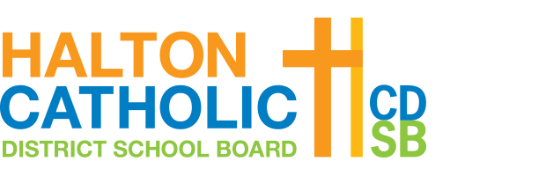

|  |
| --- |
| **Who We Are:** |
| Holy Rosary-Milton School together with home, church, and community encourages within each child a love of learning and a desire to do one’s best. |

