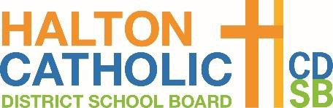
S

The Ministry can direct school boards and schools to perform daily on-site confirmation of self-screening for all students, staff and visitors. At this time, the Ministry is requiring school boards and schools to implement the daily on-site screening for all elementary students until further notice.

Parents/guardians/students must complete the Ontario School Screening Tool each morning prior to or upon arrival for each student.

Daily Confirmation of COVID-19 Screening for Students Attending School In-Person
Confirmation of the daily screening must be provided to the classroom teacher in one of the following formats:
- Email results to classroom teacher;
- Show “pass” confirmation on a personal device;
- Show printed copy of the screening tool indicating the current date and a “pass”; OR
- Complete Confirmation of Daily COVID-19 Student Screening Log, which the student(s) will bring back and forth to school each day.

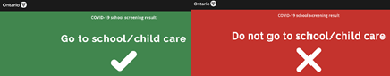
The screening will indicate one of two results:
Students only attend school if a “✅” is obtained.
Students with COVID-like symptoms or who receive an “X” indicating “Do not go to school" must remain home and isolate as instructed.

Parents/guardians of students requiring assistance, including students with special education needs, are asked to complete a Confirmation of Daily Covid-19 Student Screening Log (below) that accompanies the student from home to school and is signed each day by the parent/guardian completing the Ontario School Screening Tool.

Staff will:
- Verify the “pass” confirmation of the Ontario School Screening Tool for each student attending in person each day or via the written log.
- For an incomplete log entry staff should follow-up with the parent/guardian by phone or email to complete the school screening process.
No student data (e.g., screenshot, pdf, paper confirmation, etc.) will be retained by the school.

Daily Staff and Visitor Confirmation of Screening
Staff and visitors are required to complete the COVID-19 School Screening Tool each day and confirm daily screening, prior to or upon arrival at school, using the QR Code or link provided by your school.

Any individual that does not pass the on-site screening procedures will be asked to return home and self-isolate until they meet the criteria for return.

Principal or designate will:
- Verify the “pass” confirmation of the Ontario School Screening Tool for all staff and visitors.

(School Name) Confirmation of Daily Covid-19 Student Screening Log

Student Name : Class : (Please Print)

Parent/Guardian Name: Date :
(Please Print)

Verify in writing: |  | Verify electronically: https://covid- 19.ontario.ca/school- screening/  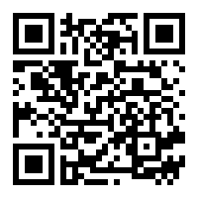  Students may alternatively complete screening on their own device, where age appropriate, and present on arrival.
I/we confirm the student (above) received a “pass” on the COVID School Screening Tool.

Parent/Guardian Name (Print) Parent/Guardian Signature

Please initial each morning prior to attending school.

By initialing below, I/we confirm the Ontario COVID-19 School Screening has been completed for my child and my child has passed the screening.

Date | Parent/guardian initials
January 17, 2022
January 18, 2022
January 19, 2022
January 20, 2022
January 21, 2022
January 24, 2022
January 25, 2022
January 26, 2022
January 27, 2022
January 28, 2022

January 31, 2022
February 1, 2022
February 2, 2022
February 3, 2022
February 4, 2022
February 7, 2022
February 8, 2022
February 9, 2022
February 10, 2022
February 11, 2022

