ADVENT MESSAGE

Dear Friends in Christ:

Greetings in the Lord! As the joyful celebration of Christmas approaches, the Church invites us to enter the season of Advent. This short season of the Church Year is a time of joyful waiting and expectation. At this time we affirm our hope in the Lord’s return in the fullness of time and we prepare to commemorate His birth two thousand years ago. Advent helps us reflect on the ways in which we are called to bring the Saviour’s love and life to birth in our own lives.

This brochure will highlight our parish’s celebration of the season of Advent and the liturgical celebration of Christmas. If you have any questions about this information please do not hesitate to call our parish office.

I pray that this season of Advent will be a grace-filled opportunity for you and your family to prepare for the birth of the Prince of Peace. Please know that you are remembered weekly in our Sunday celebration of the Eucharist.

Wishing you and your family a very Merry Christmas!

Father James S. Petrie
Pastor

SACRAMENT OF RECONCILIATION
(Confessions)

The Sacrament of Reconciliation is celebrated each Saturday afternoon from 4:00 – 4:30 pm in the Prayer Chapel by the front doors of Our Lady of Fatima Catholic Elementary School (709 Bolingbroke Drive in Milton).

On December 15th and 22nd, Confessions will be heard from 3:30 – 4:30 pm to provide additional opportunities for parishioners to celebrate this beautiful sacrament.

On Thursday December 13th, there will be a communal celebration of the sacrament of reconciliation for both parishes in Milton. It will take place at Holy Rosary Parish (139 Martin Street in Milton). It will begin at 7:00 pm. Several priest confessors from the region will be available for the celebration of individual confessions at that time.

There will be NO CONFESSIONS after December 22nd. Please do not wait till the last minute to celebrate the sacrament. Reconciliation is a wonderful way to prepare ourselves for the celebration of the Birth of our Lord.

SCHEDULE OF CHRISTMAS MASSES
(all Masses take place at Our Lady of Fatima Catholic Elementary School located at 709 Bolingbroke Drive in Milton)

Monday December 24th – Christmas Eve

4:00 pm
6:00 pm
9:00 pm

Tuesday December 25th – Christmas Day
Solemnity of the Birth of Jesus Christ

9:00 am
11:00 am

There are NO AFTERNOON or EVENING MASSES celebrated on Christmas Day anywhere in the Diocese of Hamilton

All of our Christmas Masses are appropriate for children and families. To avoid large crowds and congested parking, you may wish to consider attending Mass on Christmas morning at 9:00 am or 11:00 am.

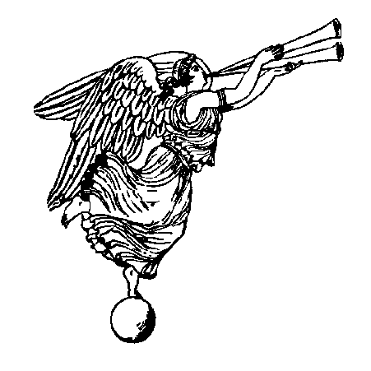

PREPARING OURSELVES FOR THE CELEBRATION OF THE BIRTH OF JESUS IN OUR LIVES AND FAMILIES

Advent has a two-fold nature: it prepares us for Christmas, when we recall the Lord’s first coming among us, and it is also a time when we look forward to His second coming at the end of the world. Advent is a season of joyful expectation.

The Sunday Scripture readings during Advent reflect this two-fold nature of the season. The Old Testament readings (first reading) are generally taken from the prophet Isaiah and point us towards the coming Messiah. The New Testament readings (second reading) are selections from the apostles on the different themes of Advent.

The Gospels for the Sundays of Advent might be a helpful guide for spiritual reading during this season – you may wish to read these passages and use them for prayer prior to the Sunday Mass:

1st Sunday of Advent Luke 21:25-28, 34-36

2nd Sunday of Advent Luke 3:1-6

3rd Sunday of Advent Luke 3:10-18

4th Sunday of Advent Luke 1:39-45

OTHER CELEBRATIONS IN THE CHRISTMAS SEASON

Feast of the Holy Family
Saturday December 29th
5:00 pm
Sunday December 30th
9:00 am and 11:00 am

Solemnity of Mary the Mother of God
Monday December 31st
5:00 pm
Tuesday January 1st, 2019
9:00 and 11:00 am

Solemnity of the Epiphany
Saturday January 5th
5:00 pm
Sunday January 6th
9:00 and 11:00 am

** All Masses take place at
Our Lady of Fatima
Catholic Elementary School
located at 709 Bolingbroke Drive in Milton**

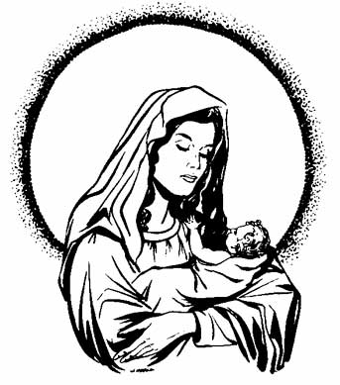

SEASONS OF ADVENT AND CHRISTMAS
2018-2019

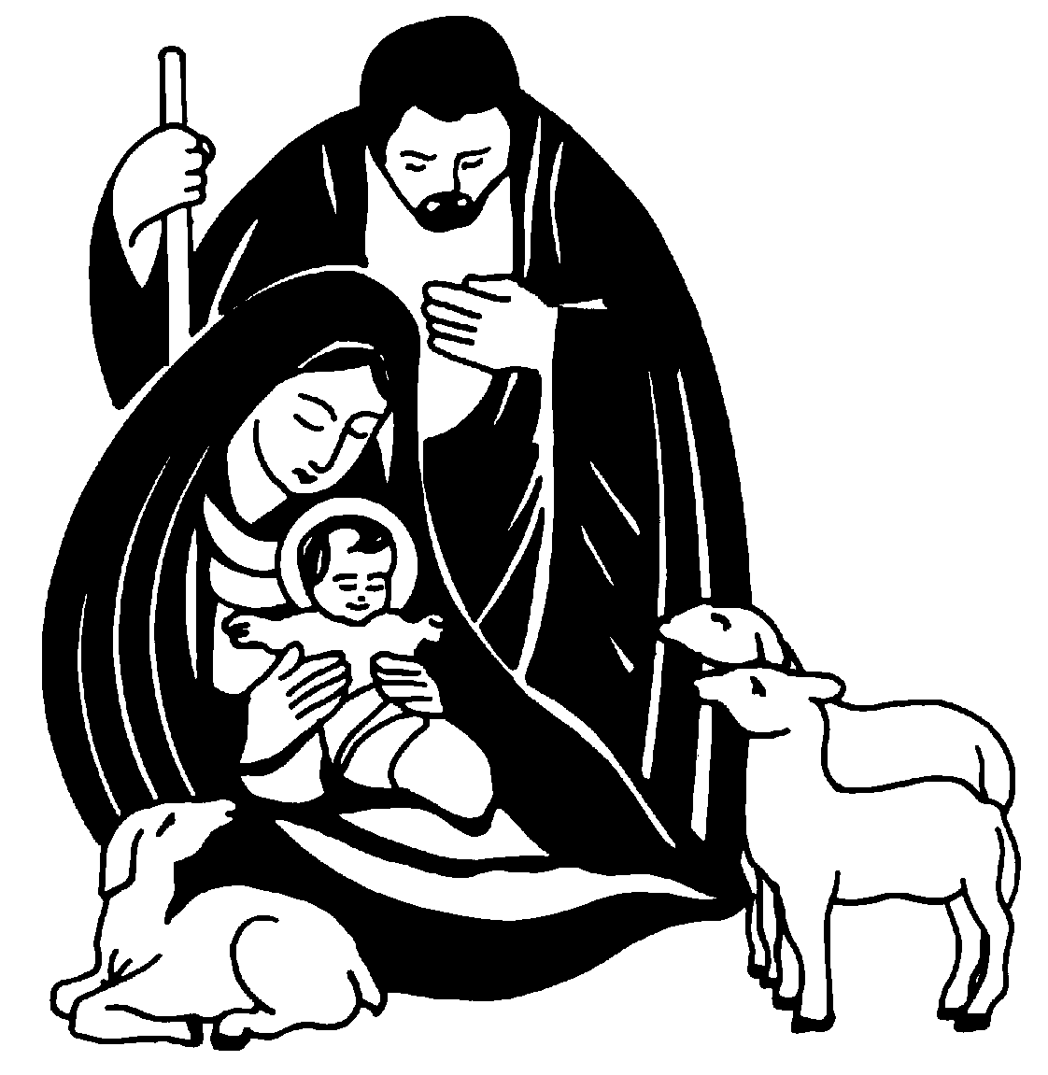

SAINT BENEDICT
ROMAN CATHOLIC PARISH

1069 Kelman Court
Milton, ON. L9T 2W3

289-878-3118

stbenedictmilton@gmail.com
www.stbenedictparish.ca

